Video and Discussion Guide

TED Talk:
Why Domestic Violence Victims Don’t Leave

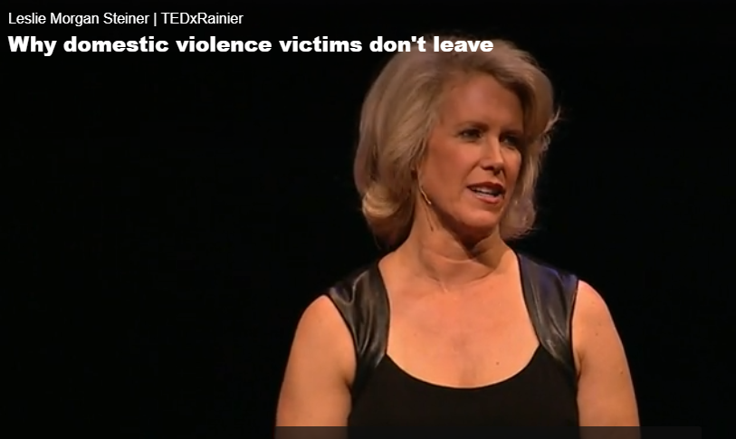
Speaker: Leslie Morgan Steiner
Year of talk: 2012
Length: 15:53 min
English level: Medium
Themes: Gender-Based Violence; Women’s Empowerment
https://www.ted.com/talks/leslie_morgan_steiner_why_domestic_violence_victims_don_t_leave?referrer=playlist-let_s_end_the_silence_around_a

Link:

TED is a nonpartisan nonprofit devoted to spreading ideas, usually in the form of short, powerful talks. TED began in 1984 as a conference where Technology, Entertainment and Design converged, and today covers almost all topics — from science to business to global issues — in more than 100 languages. (From https://www.ted.com/about/our-organization)

Please note:
- American Spaces Coordinators should work together with their Public Affairs Sections in planning programs for the American Space, and to determine appropriate programming themes and content.
- Ted Talk videos are available for download. This is recommended for American Spaces with low or unstable bandwidth.

Context (from Ted Talk summary)
Leslie Morgan Steiner was in "crazy love" -- that is, madly in love with a man who routinely abused her and threatened her life. Steiner tells the story of her relationship, correcting misconceptions many people hold about victims of domestic violence, and explaining how we can all help break the silence.

About the Speaker (from https://www.ted.com/speakers/leslie_morgan_steiner?referrer=playlist-let_s_end_the_silence_around_a)
Leslie Morgan Steiner is the author of Crazy Love, a memoir about her marriage to a man who routinely abused and threatened her. Steiner received her MBA in marketing from Wharton School of Business and worked in marketing for Johnson & Johnson before transitioning to writing, as General Manager of the Washington Post Magazine. Steiner writes a weekly column called "Two Cents on Modern Motherhood," for the website Mommy Track’d.

Key Vocabulary
- Chokehold – a way of holding someone with your arm tightly around the person’s neck, so the person cannot breathe easily.
- Domestic violence – violence or other abuse by one person towards another person within the home, typically the abuse of a spouse or partner. According to the U.S. Department of Justice, domestic violence is a pattern of abusive behavior in any relationship that is used by one partner to gain or maintain control over another intimate partner. Types of abuse include: physical abuse, sexual abuse, emotional abuse, economic abuse, psychological abuse, threats, stalking, and cyberstalking.
- Ivy League degree – a degree from one of the eight old and distinguished U.S. colleges/universities in the Eastern U.S. known for their ivy-covered buildings. Ivy League universities have reputations for academic excellence and include Harvard, Yale, Princeton, Columbia, Cornell, Brown, Dartmouth, and University of Pennsylvania.
- New England – the region located in the northeast corner of the USA, and includes the following six states: Connecticut, Maine, Massachusetts, New Hampshire, Rhode Island and Vermont.
- Stalking – unwanted or repeated surveillance by one person/party towards another person/party. This includes harassing and following victims in person and/or monitoring them.
Discussion Questions
- What is Ms. Steiner’s background? According to Ms. Steiner, who does domestic violence happen to?

Ms. Steiner has a B.A. in English from Harvard College, an MBA from Wharton Business School, and she has spent most of her career working for Fortune 500 companies including Johnson & Johnson and The Washington Post. According to Ms. Steiner, “domestic violence happens to everyone – all races, all religions, all income and education levels.”

- What was the background of Ms. Steiner’s husband, Connor? How did he abuse his wife?

He graduated from an Ivy League school, and he worked at a Wall Street bank. He idolized Ms. Steiner in the beginning, and he believed in her hopes and dreams. He also shared his secret that as a young boy, he was routinely physically abused by his stepfather, and the abuse had gotten so bad, he had to drop out of school in the 8th grade.

After persuading Ms. Steiner to move to a more remote area, he bought three guns; he said he needed these to feel protected. He first physically attacked Ms. Steiner five days before their wedding, and using a chokehold to hit her head against the wall. He then beat her on their honeymoon, and would beat her 1-2x a week for the next 2.5 years of marriage.

- What does Ms. Steiner say for why she stayed in the relationship?

She said she didn’t know he was abusing her. Even though he held guns to her head, pushed her down the stairs, poured coffee grinds on her head, she never once thought of herself as a battered wife. Instead, she thought she was a strong woman in love with a deeply troubled man, and she was the only person who could help Connor face his demons.

- Why didn’t Ms. Steiner just leave in the beginning? And how was she able to eventually leave?

She said this is the saddest and most painful question that people ask since victims know that it’s very dangerous to leave an abuser; the final step in the domestic violence pattern is to kill the victim.

She was eventually able to leave because of one terrible beating that “broke through her denial [that she was not a battered wife].” She broke the silence and told everyone – the police, her neighbors, friends and family, and strangers.

- What kind of support and resources exist for victims of violence in our communities?

- What further steps can we take to help victims of violence? As a society, what steps can we take to prevent domestic violence in the first place?

Subtitles for this TED Talk are available in 41 languages. A transcript of the talk is also available here (41 languages available)::

https://www.ted.com/talks/leslie_morgan_steiner_why_domestic_violence_victims_don_t_leave/transcript?referrer=playlist-let_s_end_the_silence_around_a

