American Spaces Programming Resources

50th Anniversary of the Apollo Program and the First Manned Moon Mission

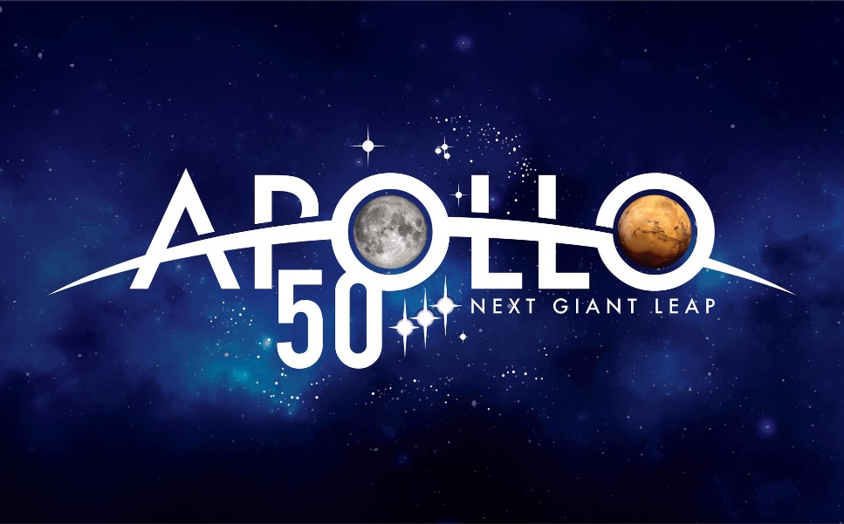

Image from: https://www.nasa.gov/specials/apollo50th/media.html

Please note:
The resources provided here are not required programs. The Office of American Spaces recommends collaborating with the U.S. Embassy’s or Consulate’s Public Affairs Section on the programs offered in American Spaces.

From October 2018 through December 2022, the U.S. National Aeronautics and Space Administration (NASA) will mark the 50th anniversary of the Apollo Program that landed a dozen Americans on the moon between July 1969 and December 1972. NASA has released many resources, including logos, educational lesson plans, posters, audio and video content, and more to commemorate this anniversary.

Programming Resources

- NASA Resources (https://www.nasa.gov/specials/apollo50th/)

  - Excellent Overview of the Apollo Program: https://www.nasa.gov/audience/forstudents/5-8/features/nasa-knows/what-was-apollo-program-58.html

  - NASA Apollo 50 Missions https://www.nasa.gov/specials/apollo50th/missions.html

  - NASA Apollo Missions for Teachers https://www.nasa.gov/mission_pages/apollo/index.html
    - Educational Lesson Plans for Students – Grades K-12 (eight different lesson plans/projects featured; projects appropriate for American Spaces audiences) https://www.jpl.nasa.gov/edu/news/2019/5/29/celebrate-the-50th-anniversary-of-nasas-apollo-moon-landing-with-educational-resources-and-projects-for-kids/

- National Education Association
(Includes a range of lesson plans on the moon landing, Apollo landing sites, the background of the space program, and more)
  - http://www.nea.org/tools/lessons/63339.htm

- Smithsonian National Air and Space Museum

  - https://airandspace.si.edu/learn/highlighted-topics/apollo/apollo-50

- Space Outreach Toolkit of Programming Resources from Office of American Spaces

  - https://app.box.com/s/mtl9tbti3e5zq3rl3760gboq1j6kxzd2 *

- Space Diplomacy: Charting New Pathways Slide Deck
(Includes a range of specific programming resources for American Spaces coordinators, including videos, experiments, books, movies, and more)
- https://docs.google.com/presentation/d/1idbly071uHF9GY_LmKVkeQ3iC0poECgNQILAkSqikZI/edit#slide=id.g55db0b8fd4_0_31 (this link requires an America.gov account)

- Consider hosting a Space Apps Challenge in 2019

- Now it its 8th year, NASA’s International Space Apps Challenge is an international hackathon for coders, scientists, designers, storytellers, makers, builders, technologists, and others in cities around the world, where teams engage with NASA’s free and open data to address real-world problems on Earth and in space.)

  - https://americanspaces.state.gov/nasa-2019-international-space-apps-challenge/

- Consider hosting the “Beyond the Moon” Photo Exhibition in your American Space

  - Photo Exhibition developed by Public Affairs Section Kuala Lumpur with their partner EngageMedia
  - https://americanspaces.state.gov/beyond-the-moon-photo-exhibition/

Videos
- NASA Apollo 50 Mission videos
  - https://www.nasa.gov/specials/apollo50th/videos.html

- U.S. President John F. Kennedy’s “We choose to go to the Moon” speech
  - 18 minutes, speech delivered on September 12, 1962 at Rice University.
  - "We choose to go to the Moon" is the famous tagline of a speech about the effort to reach the Moon delivered by United States President John F. Kennedy to a large crowd gathered at Rice Stadium in Houston, Texas on September 12, 1962. The speech was intended to persuade the American people to support the Apollo program, the national effort to land a man on the moon (Wikipedia).
  - Full speech: https://www.youtube.com/watch?v=QAmHcdwKgtQ
  - 2-minute highlights version: https://www.youtube.com/watch?v=g25G1M4EXrQ

Documentaries available through Alexander Street
(Free through e-LibraryUSA: https://elibraryusa.state.gov/index.html, please log into e-LibraryUSA first, and then click on the links below)

- Modern Marvels, Season 7, Episode 3, Apollo 13
  - 46 mins; produced by Don Cambou; released in 2000; A&E Television Networks
  - This documentary re-enacts the events of the Apollo 13 space mission. An explosion in the spacecraft's oxygen tank forces the crew to abort the lunar landing. Despite failures to the command and service modules, the spacecraft manages to land safely on Earth.

- Modern Marvels, Season 10, Episode 25, Apollo 11
  - 44 mins; produced by Don Cambou; released in 2004; A&E Television Networks
  - See and experience the historic flight through the eyes of the astronauts, mission controllers, engineers, and designers who made it happen. NASA insiders and the astronauts themselves reveal what it was like in the capsule and command center. See the historic footage of man's first moon landing.

- NASA: 25 Years of Glory, Apollo 16: Nothing So Hidden
  - 27 mins; published by NASA; released in 1972
  - This documentary, from National Aeronautics and Space Administration, is about the Apollo 16 mission.

- Tech Effect, Apollo 11
  - 22 mins; published by A&E Television Networks; released in 2004
  - A range of technological advances make the Apollo 11 moon landing successful.

- NASA: 25 Years of Glory, Flight of Apollo 11: The Eagle Has Landed
  - 28 mins; directed by Ted Lowry; published by NASA; released in 1969
  - This documentary is about the flight of Apollo 11.

- Man Moment Machine, 1, Apollo 13: Triumph On The Dark Side
  - 45 mins; directed by Michael McInerney; published by A&E Television Networks; 2006
  - This documentary re-enacts the events of the Apollo 13 space mission. After aborting the lunar landing due to an explosion in the spacecraft's oxygen tank, the flight crew manages to land safely on Earth.

- NASA: 25 Years of Glory, Apollo 15: In the Mountains of the Moon
  - 28 mins; produced by Don Wiseman; published by NASA; released in 1971
  - This documentary is about the Apollo 15 mission.

- NASA: 25 Years of Glory, Apollo 13: Houston, We've Got a Problem
  - 28 mins; produced by Don Wiseman; published by NASA; released in 1972
  - This documentary is about the Apollo 13 mission.

- NASA: 25 Years of Glory, NASA: The 25th Year
  - 50 mins; published by Eastman Kodak Company; released in 1983
  - This documentary provides a retrospective of the accomplishments of the U.S. space program in its first 25 years. Traces the steps of Explorer I, Mercury, Gemini, Apollo, Skylab, Space Shuttle, Space Station, Viking, & Voyager programs.

Kanopy Films (Free through e-LibraryUSA: https://elibraryusa.state.gov/index.html)
- For All Mankind: The Apollo Space Missions (released 1989)
  - 81 minutes – Sorting through nearly one hundred hours of film and sound recordings recovered from NASA - shot between December 1968 and November 1972, Director Al Rienart has pieced together a seamless documentary commemorating the 24 men who travelled to the moon.
- Blast! The Secrets of Outer Space (released 2006/2007)
  - 132 minutes (2 videos) – This film takes a journey across five continents, from Arctic Sweden to Antarctica, to try and unravel the secrets of outer space.
- Women in Space -- Part of PBS Series – Makers: Women Who Make America (released 2014)
  - 57 minutes – Makers: Women in Space traces the history of women pioneers in the U.S. space program.

Suggested Movies Covered Under MPLC Licensing Agreement
- https://americanspaces.state.gov/programming/the-motion-picture-licensing-corporation-agreement/)
- Visit the Managing American Spaces website to find suggested movies covered by the Motion Picture Licensing Corporation (MPLC) agreement that may be shown as part of African American History Month. For a listing of ECA-suggested film titles:
- Under the first FAQ (Suggested Film Titles by Category/Genre/Theme), click on “list of film titles (xlsx 754kb)”
- On the bottom of the spreadsheet, scroll to the tab “Space Travel”

- Note: The inclusion of each title represents a suggested and/or potentially relevant film, not an endorsement. All posts/Spaces are advised to preview film titles ahead of time before public screenings to ensure that all thematic material and content are culturally and programmatically appropriate for their intended audiences.
- Posts will need to procure films on own.

Film Programming Packages
- Films:
  - The Martian: 1 hour 42 minutes – After an astronaut becomes stranded on Mars, he must figure out how to survive and send a message to Earth that he is alive.
  - Hidden Figures: 1 hour 29 minutes – An inspirational story of three female African-American mathematicians who were able to overcome adversity and play a critical role for their country with their contributions to the American space flight program.
- Movie Programming Kits* (accessible here: The Martian ; Hidden Figures )
- Posts/American Spaces need to procure film on own

eShop Collections
*eShop collections include a selection of products, including books, games, posters, kits, etc, on specific topics that may be used for programs to engage target audiences.
- Space -- https://eshop.state.gov/STEM/Space
- Moon Landing High-Resolution Graphic -- https://eshop.state.gov/Moon%20Landing

Written/Photo/Video Resources
- Share America articles
  - Space, NASA articles-- https://share.america.gov/?s=space; https://share.america.gov/?s=nasa

- Photos
  - NASA Apollo 11 (1st Moon Landing) photo gallery -- https://www.nasa.gov/apollo11-gallery
  - NASA Apollo 50 Mission Emblems https://www.nasa.gov/specials/apollo50th/photos.html
  - IIP Space Photo Archive -- https://www.flickr.com/photos/iip-photo-archive/sets/72157665028512494

- Downloadable Posters
  - NASA Apollo 50 Downloadable Posters https://www.nasa.gov/specials/apollo50th/media.html
  - Share America – 50th anniversary of the first moon landing -- https://share.america.gov/50th-anniversary-of-the-first-moon-landing-poster/
  - eShop Moon Landing High-Resolution Graphic -- https://eshop.state.gov/Moon%20Landing

*Note: Linked files are on the “Box” platform. As you click on the link, if you see a message that says, “We’re sorry, the preview didn’t load,” please disregard this message and click on the “Download” button on the top right. You can also copy and paste the link on a new page using another web browser, such as Google Chrome. If these instructions do not work, please email americanspaces@state.gov.

