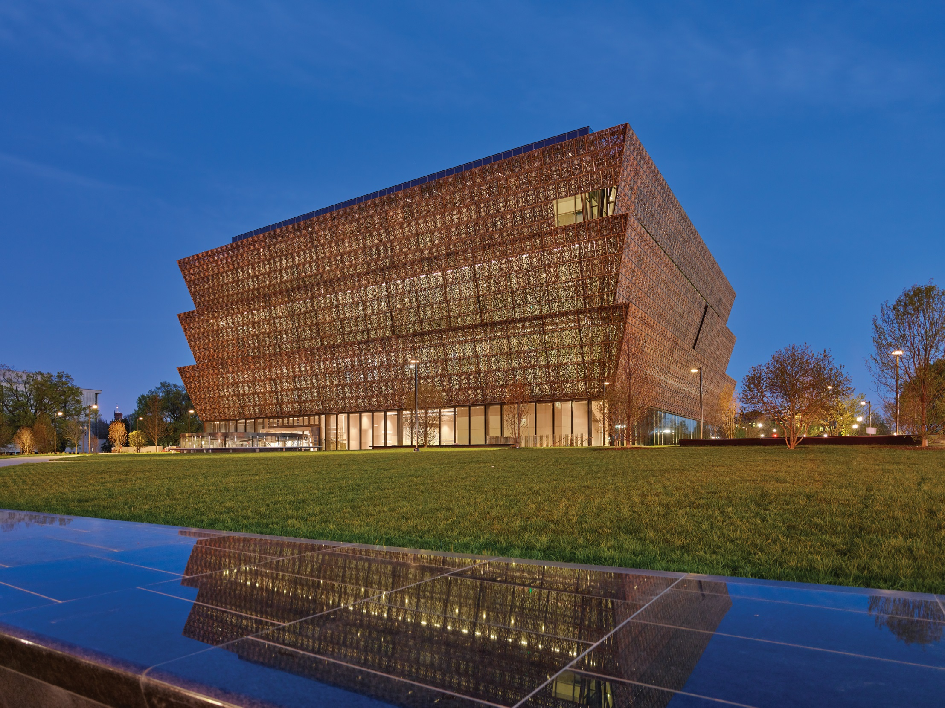
Highlights from the Smithsonian Institution’s
National Museum of African American
History and Culture
15 Finds for American Spaces Programming

March 2017
Introduction
The Smithsonian Institution’s National Museum of African American History and Culture (NMAAHC) opened in September 2016 to national celebration after more than 100 years of anticipation. The museum showcases the struggles and successes of African Americans, and their vital contributions to the culture of the United States. It has been praised for its thoughtful, sensitive, honest, and hopeful portrayal of African American life and history.

What is this program?
Created for American Spaces, this module presents fifteen object highlights of the NMAAHC collection – only a small fraction of the museum’s rich holdings – for use in a variety of programs. These fifteen objects are intended to illustrate important moments in African American history and the broader history of the United States. Objects were selected to highlight U.S. foreign policy priority themes, which range from U.S. history and culture, to civil rights, civic engagement, and women’s empowerment. Objects are both personal and historical, tied to famous figures like Rosa Parks and Malcolm X, and to everyday individuals who were themselves part of local history.

Each entry includes:
- Object name and credit line
- Image thumbnail for quick visual reference
- Highlighted themes for programming
- Brief description of the object, including associations with historical events or figures
- Conversation questions to promote engagement and thoughtful discussion
- Selected resources for additional information or programming materials, such as useful blogs, articles, or videos. These resources are intended to provide programming ideas and inspiration. The Smithsonian does not endorse the products or services of outside organizations referenced in this module.

These objects are intended to spark thought and discussion among program participants. They connect with issues of justice, identity, expression, and society. We have included three to seven suggested discussion questions for each object to deepen participant engagement. Many more questions will undoubtedly come up as participants examine, research, and think about these objects. Our hope is to provide you with background on objects that participants can relate to their own contexts.

How can I use this material for programming?
This content can be used in a variety of ways and can be linked to foreign policy priority themed programming. You could consider using these materials in conjunction with a program during Black History Month or with programs focused on promoting tolerance and inclusion or the value of civic participation. Here are a few ideas to get you started!

Host a Poster Show. Use the high-resolution images provided to create a customizable poster show in your space. You could use the image descriptions provided in the module for text overlays or text labels to provide context and background information about the object or moment in U.S. history. Use the suggested conversation questions to encourage and promote thoughtful dialogue.
Extension: What are objects that help to illustrate or explain local history or cultures? Ask participants to brainstorm ideas for important moments in local history and culture and encourage participants to research a specific event or historic figure that helped contribute to local history. What are some local objects that could be used to convey these events? Participants can present their research to the group for additional English language learning.

All of these images have been provided for educational use courtesy of NMAAHC, so when using these images for poster shows, or otherwise, please use the credit line included for each object.

Use on Social Media. Use these images on social media to promote an event around a specific theme such as Black History Month, civic engagement, nonviolent protest, or civil rights. When you use these images, please be sure to use the credit line provided from NMAAHC.

Create a Digital Gallery. Post these objects and descriptions on your social media account throughout Black History Month or leading up to a program on a related theme. Encourage your followers to share comments about how the objects connect with their own experiences or with local history and culture.

English Language Learning. Use the conversation questions to encourage discussion about the objects and their significance to African American and U.S. History. The conversation questions are intended to broaden awareness of U.S. history, historical marginalization of individuals, civil rights, and civic engagement, all while making connections between the past and the present, both locally and in the U.S.

Identify any vocabulary words that might be difficult to program participants. Encourage them to provide their own definitions of these words after using a dictionary or online reference tool.
Extension: Some of the objects listed here, like Joseph Trammell’s freedom papers and Harriet Tubman’s hymnbook, came to NMAAHC from individual donors whose families had previously held these items for generations. Consider encouraging each participant to bring in an object (or a photograph of an object) that is important to their family. Ask each participant to give a brief presentation on how the object came to them, how it connects with their local or national history, and what it means to them.

Research Projects and Presentations. Ask participants to research and present on one of the objects. Encourage them to use the additional resources provided for each item, and to seek more information about the object and its context. The additional resources provided can help provide a starting point for research. Ask them to give brief presentations and lead a discussion about their object. This exercise could help strengthen presentation and English language skills.

Visit a local museum. Use these objects, personal objects, or objects in a local museum to lead a discussion about material culture. Why is it important to collect objects, for individual families and in museums? How can seeing and touching objects teach us about other people’s lives? What can objects tell us that written sources cannot? Consider asking participants to write or present a brief report on material culture in their own contexts.

Factsheets. Use the image and the description to create handouts for program participants. Consider providing the entire set of objects or selecting only a few that relate most to the theme of your program. Encourage participants to read the descriptions aloud with a partner.

Create a Banner. Have participants make their own slogan banners, similar to the “Lifting As We Climb” banner. Ask them to think about a slogan that represents an important value or cause in their community, and to set and decorate it on a paper or cloth banner. Encourage each participant to present their banner and explain their slogan or motto to the group for additional English language learning.

Invite a Guest Speaker. Invite a local historian or civil rights activist to present on his/her area of expertise to lead a discussion.

Be Bold. Get Creative! Use this material to be inspired to create your own, innovative and engaging program for your American Space audience.

Accessing the Images
All images can be accessed by visiting: https://americanspaces.state.gov/programming/additional-programming-resources/national-museum-of-african-american-history-culture-program-package/
We’ve provided thumbnail versions for you to preview the image. There are three different file types provided for each of the objects, optimized for use in-person or online. Download times will vary; the file types and intended uses are listed below:

TIF: These are high-resolution files intended for printing for a poster show. File sizes are large, so these will take longer to download.
JPEG: There are two different types of JPEGs provided, print and web. File sizes are typically smaller, so download times are faster than a TIF. The images for print can be used on program handouts, worksheets or flyers. The images for web can be integrated into social media platforms for promoting your program.

Image Rights
All of the high resolution images in this package are licensed for educational use, and may be shared on websites and social media accounts linked to the State Department, U.S. Embassies, and American Spaces and partners. Please use the credit line listed with the image when using these images in print or online.
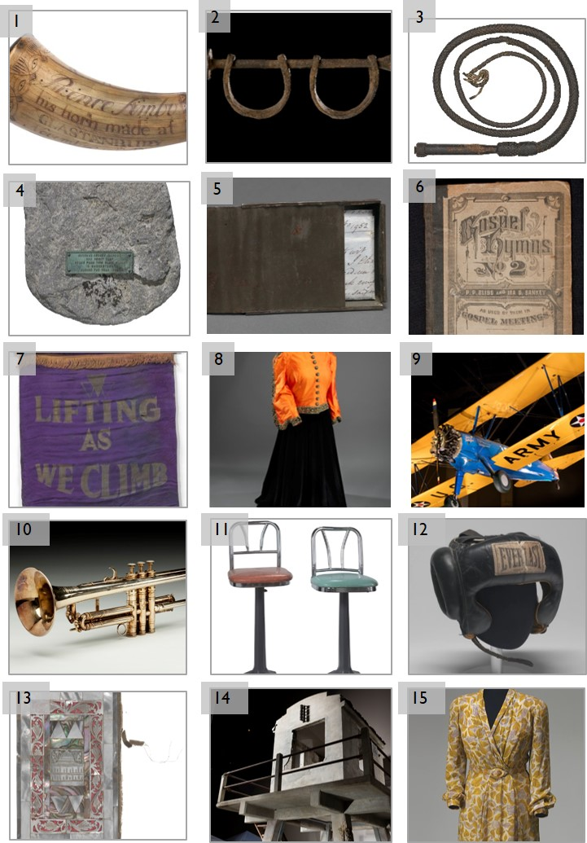
15 Highlighted Objects
The following is a list of the objects included in this program module.

- Prince Simbo powder horn: Engraved powder horn carried by Prince Simbo, a free black soldier who fought in the Revolutionary War.
- Slave shackles from the Middle Passage: Iron shackles used to restrain enslaved children aboard a slave ship crossing the Atlantic Ocean.
- Field whip: Leather whip used to enforce the cotton harvest on a slave plantation.
- Stone slave auction block from Hagerstown, Maryland: Stone block where enslaved African Americans stood during slave auctions.
- Freedom papers and handmade tin carrying box belonging to Joseph Trammell: Virginia Certificates of Freedom certifying Joseph Trammell’s free status.
- Harriet Tubman hymnbook: Harriet Tubman’s copy of Gospel Hymns No. 2, by P.P. Bliss and Ira D. Sankey.
- Banner with motto of Oklahoma Federation of Colored Women's Clubs: A purple silk banner bearing the inspiring motto of the National Association of Colored Women’s Clubs.
- Marian Anderson Ensemble: The orange silk jacket and black velvet skirt Marian Anderson wore during her performance on the steps of the Lincoln Memorial on Easter Sunday 1939.
- Tuskegee Aircraft: An open-cockpit biplane used for training pilots at the Tuskegee Institute during the World War II.
- Louis Armstrong’s trumpet: One-of-a-kind trumpet, owned and played by Louis Armstrong.
- Lunch counter stools from Greensboro sit-in: Stools from the lunch counter at Woolworth’s department store in Greensboro, North Carolina, the site of a famous and successful anti-segregation protest.
- Muhammad Ali’s Headgear: Protective headgear of world heavyweight champion Muhammad Ali.
- Koran owned by Elijah Muhammad: A richly decorated Koran that belonged to Elijah Muhammad, leader of the Nation of Islam.
- Guard tower from Angola Prison: Concrete guard tower used to survey prisoners at Louisiana State Penitentiary, a prison built on a former slave plantation.
- Rosa Parks’ Dress: Dress that Civil Rights activist Rosa Parks was making for herself at the time of her arrest for defying segregation on a Montgomery bus in 1955.

Object Name  and Image | Prince Simbo Powder Horn  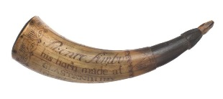  Credit Line: Collection of the Smithsonian National Museum of African  American History and Culture
Themes | Activism, U.S. History, Military, Slavery, Freedom
Description | Prince Simbo was an African American man who served in the Revolutionary War on the side of the United States. What little is known about him comes from this engraved powder horn and two military documents bearing his name. We know that he enlisted in 1777, and that he lived in Glastonbury, Connecticut, where slavery was legal at the time. He was likely free, as it was unusual for enslaved people to serve in the Continental Army. Many people of African descent fought for liberty in the Revolutionary War, in the hopes of ensuring their personal freedom. This was a gamble, as only some states abolished slavery after the War.  Powder horns were typically carved from cows’ horns, and were used to hold gunpowder and keep it dry. Prince Simbo’s powder horn displays carvings that he probably engraved himself, including images of a dove, a sun, a pine tree, and a repeating eye motif. The word “Liberty,” engraved on the back of the horn, evokes Prince Simbo’s hopes for the future. With these engravings and personal touches, the horn is a unique record of Prince Simbo’s own personality.
Conversation Questions | - Why is it important to keep personal objects? How do personal belongings help us understand history?  - Examine the carvings on the horn. What are the symbols? Why might Prince Simbo have chosen these symbols? What are some symbols you might choose to decorate an object you use every day?  - Why might an African American support the United States in the Revolutionary War? What choices could African Americans make to improve their lives during this period?  - Why might Prince Simbo have chosen the military? Why do people in your community choose to serve in the military? What does it mean to serve in the military in your country?  - What are the risks of serving in the military? Why might somebody want to take those risks?  - What might “Liberty” have meant to Prince Simbo personally? What do you think it meant to him as an American? What does liberty mean to you?  - Standing up for yourself often requires courage and sacrifice. Can you describe a time when you stood up for something you believe in?
Resources  for more information | “The Revolutionary War Patriot Who Carried This Gunpowder Horn Was Fighting for Freedom – Just Not His Own,” article, Smithsonian Magazine http://www.smithsonianmag.com/smithsonian-institution/patriot-who-carried-revolutionary-war-era-gunpowder-horn-was-fighting-freedomjust-not-his-own-180959385/  “Stories From The Revolution: African Americans In The Revolutionary Period,” article, National Park Service  https://www.nps.gov/revwar/about_the_revolution/african_americans.html  “Fighting…Maybe for Freedom, but Maybe Not,” article, Colonial Williamsburg Journal  http://www.history.org/Foundation/journal/Autumn07/slaves.cfm

Object Name | Slave shackles from the Middle Passage  Credit Line: Collection of the Smithsonian National Museum of African American History and Culture
Themes | Slavery, Family, Freedom, Economy, Human Trafficking
Description | From the 17th century onward, European settlers began to build rice, sugar, and tobacco plantations in America as a way to make money. As demand for these items grew in Europe, planters needed massive amounts of labor to keep their plantations running. The Trans-Atlantic Slave Trade fed settlers’ demands for labor with enslaved people, kidnapped from the Western coasts of Africa and brought by ship to America. A triangular trade circuit developed, in which ships brought raw materials from America to Europe, manufactured goods from Europe to Africa, and enslaved people from Africa to America. During the four centuries of the Trans-Atlantic Slave Trade, an estimated 11 to 15 million people were brought from Africa to America, with approximately one million remaining in North America.  The Middle Passage of this route between Africa to America was notoriously brutal. Enslaved people were crammed into dark, airless holds, with no room to stand up, or even to turn over. People were shackled to the floor to keep them from moving around. Often there was little food and unclean conditions. Disease spread quickly in these crowded, dirty conditions, and nearly one in three enslaved people died during the journey.  It’s difficult to tell from the photograph alone, but the small size of these shackles indicates that they would have been used to restrain a child. Slave traders captured men, women, and children, separating families and communities to discourage revolt. These shackles are a powerful object that personalize the appalling history of slavery that built the early American economy.
Activity Suggestions | Have participants read through the online exhibition “On the Water: Forced Crossings,” from the National Museum of American History before encouraging them to watch the interactive map video from Slate Magazine’s “The Atlantic Slave Trade in Two Minutes.” What does this data tell us about the slave trade? Ask each participant to research one of the slave ships using the Voyages database before presenting their research to the group. (Links below.)
Conversation Questions | - Why might this object be kept in a museum? Why might museums display objects that tell stories linked to difficult historic events?  - How can commerce drive inhumanity and injustice?  - What are some ways to prevent business interests from taking advantage of people? What can you do to prevent injustices or inequality locally?  - Advocacy is an important component of civil societies. How could you advocate for yourself or a friend experiencing inequality or injustice?  - How can historical events affect current events? What are the challenges of addressing historical injustices?
Resources  for more information | “Few Artifacts of the Transatlantic Slave Trade Still Exist. These Iron Blocks Help Tell That Gut-Wrenching Story,” article, Smithsonian Magazine  http://www.smithsonianmag.com/smithsonian-institution/few-artifacts-transatlantic-slave-trade-exist-iron-blocks-tell-gut-wrenching-story-180959803/  “On the Water: Forced Crossings,” online exhibition, National Museum of American History  http://americanhistory.si.edu/onthewater/exhibition/1_4.html  Voyages: The Trans-Atlantic Slave Trade Database, digital database, National Endowment for the Humanities et al.  http://slavevoyages.org/
Video Resources | “The Atlantic Slave Trade in Two Minutes,” interactive video and article, Slate  http://www.slate.com/articles/life/the_history_of_american_slavery/2015/06/animated_interactive_of_the_history_of_the_atlantic_slave_trade.html
Object Name | 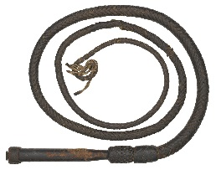  Field Whip  Credit Line: Collection of the Smithsonian National Museum of African American History and Culture, Gift of Oprah Winfrey
Themes | Slavery, Family, Freedom
Description | Whips like this one were among the gruesome tools that drove the American economy during the first half of the 19th century. The demand for cotton dramatically increased thanks to the invention of the cotton gin, which could quickly separate cotton wool from seeds and stems. From 1811 to 1860, the United States saw a 361 percent increase in cotton production. Cotton grew on plantations across the American South, where enslaved people planted, tended, and harvested up to 600 million kilograms a year. As the industry grew, the demands on enslaved plantation workers increased. In 1801 enslaved laborers were forced to pick 13 kilograms per day, but by 1840 quotas could be as much as 155 kilograms.  The cotton boom meant brutal work regimens for enslaved people, enforced through physical torture. During harvest time, slaves had to pick cotton by hand, working from sunrise to sunset in blistering heat. They worked many hours despite sleep deprivation and malnourishment. Mothers were forced to bring infants with them into the fields, and one in four infants did not survive their first year. Each harvester had to meet a set quota of cotton each day, and at the end of the day, each person’s harvest was weighed. Those who did not meet the quota were beaten or whipped. Whipping was a brutal torture that could cause people to lose consciousness, and could even cause permanent loss of mobility and brain damage. As plantation owners kept increasing quotas, whipping became more and more commonplace.  The craftsmanship of this whip suggests that whips were often a symbol of status for plantation owners—a status founded on torture and terror. Field whips like this one represent the violence on which the American cotton economy was built.
Conversation Questions | - What does this object tell you about slavery? Why do you think it was included in the museum?  - Why were cotton plantations so violent? Do you know of other situations where violence was used to produce something? How can you prevent this violence?  - Why did slavery grow in the 19th century? How was slavery tied to economics? How was slavery important for the U.S and/or world economies?  - Do you know of any unfair labor practices? Why are they unfair?  - In the U.S., people still discuss the historical effects of slavery. Why is it important to talk about these difficult moments in history? Are there difficult or troubling moments in your local history? How does your community address those parts of history?  - Slavery relied heavily on consumers purchasing goods produced on plantations. How can you be a more informed consumer to understand where and how products are manufactured today?
Resources  for more information | “Retracing Slavery’s Trail of Tears,” article, Smithsonian Magazine  http://www.smithsonianmag.com/history/slavery-trail-of-tears-180956968/  “Picking Cotton Under the Pushing System,” article, Slate  http://www.slate.com/articles/life/the_history_of_american_slavery/2015/08/slavery_under_the_pushing_system_why_systematic_violence_became_a_necessity.html  “The Experience of Slavery,” primary sources, Library of Congress  https://www.loc.gov/teachers/classroommaterials/connections/narratives-slavery/history3.html

Object Name and Image | 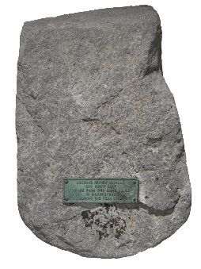  Stone slave auction block from Hagerstown, Maryland  Credit Line: Collection of the Smithsonian National Museum of African American History and  Culture, Partial Gift of Mr. and Mrs. Sean P. Guy
Themes | Civil Rights, Human Rights, Human Trafficking
Description | The Transatlantic Slave Trade does not tell the whole story of slavery in America. There was also a booming domestic slave trade, in which enslaved Africans and African Americans were sold between traders, planters, and even local government officials. The enslaved were sold at auctions that typically took place in public spaces, including taverns, hotels, courthouses, and jails.  Slave blocks were a common symbol of the domestic slave trade. Enslaved people were forced to stand on these blocks in front of prospective buyers, who subjected them to physical inspection. They were forced to stand naked, and traders would do things like rub their skin with animal fat to make them look healthier and more appealing to buyers. Sellers auctioned off the enslaved individuals with no regard for family bonds, frequently separating husbands from wives and parents from children.  This marble block, which measures about 60 by 90 centimeters in size, was used in slave auctions in Hagerstown, Maryland, in the first half of the 19th century. It stood at the front door of the courthouse, and served in officially sanctioned slave sales. Maryland was an important avenue for escapees from slavery traveling north, and the Hagerstown Sheriff’s Department profited by recapturing escapees and selling them back into slavery. Often, the sheriff would capture people from Hagerstown’s large free black community and sell them, falsely claiming they were escapees.  A small bronze plaque commemorates President Andrew Jackson’s and Kentucky representative Henry Clay’s visit to Hagerstown in 1830, but it also represents a tendency to erase the history of slavery. Many communities have blocked out their slave-holding history since emancipation, often claiming that slave blocks were actually used to mount horses. The block is also a mark of the common, public nature of slavery and the slave trade. Auction blocks in public centers are reminders that the abusive practice of slavery was not hidden or exceptional—it was part of the fabric of everyday life.
Conversation Questions | - Was slavery legal? Was it fair?  - How were enslaved people treated during auctions? Why do you think they were treated this way?  - Where did slave auctions take place? Why do you think they happened in public places?  - Is it important to remember painful/difficult moments of history? How can objects, oral histories, or other traditions help communities or families heal from these events?  - Are there any historic sites in your town or city? What do these sites mean to you or others in the community?  - Are there any objects in your community that relate to a painful/difficult part of history?
Resources  for more information | “A Slave Auction Block from Maryland,” podcast, WYPR  http://wypr.org/post/slave-auction-block-maryland  “Business of Slavery,” online exhibition, National Museum of American History  http://amhistory.si.edu/american-enterprise/business-of-slavery/  “The Slave Trade and Slave Auctions,” primary sources, Library of Congress  https://www.loc.gov/teachers/classroommaterials/connections/narratives-slavery/history2.html
Object Name and Image | 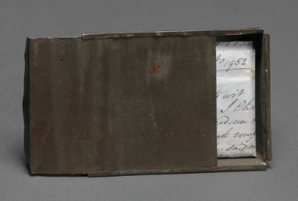  Freedom papers and handmade tin carrying box  belonging to Joseph Trammell  Credit Line: Collection of the Smithsonian National Museum of African American History and Culture, Gift of Elaine E. Thompson in memory of Joseph Trammell
Themes | U.S. History, Slavery, Civil Rights, Justice
Description | Before abolition, free African Americans lived an uncertain existence. Free African Americans had to carry documents certifying their status, which had to be renewed frequently. These documents, known as Freedom Papers, were vitally precious because any freeman traveling without papers ran the risk of being fined heavily or even sold back into slavery. Former slave Joseph Trammell registered as free in Loudon County, Virginia, in 1852, and re-registered every two years to renew his Certificates of Freedom. Freemen’s movements were restricted – Virginia did not allow freemen within state lines without special permission. So for Trammell, who probably wished to remain in Virginia for family reasons, his freedom papers were doubly precious.  The documents describe Trammell as being 170 centimeters tall and having a small scar on his forehead and a longer one on his left forearm. He was born in 1831 and died in 1859, and was twenty-one years old when these papers were signed. The tin case Trammell fashioned to carry his papers is a testament to the legal and personal value of these documents.
Conversation Questions | - Why did slave-owning states restrict the movement of free African Americans? Do you know or can you find other examples of governments restricting people’s movement?  - Why would Joseph Trammell have wanted to protect these documents? What documents are valuable to you? How do you protect them?  - Describe the type of documents you would need today to travel around the world. Do you have freedom to move around?
Resources  for more information | “Five Things to See: Slavery and Freedom,” Tumblr, National Museum of African American History and Culture  http://nmaahc.tumblr.com/post/150694091265/five-things-to-see-slavery-and-freedom-gallery  “The History Behind a Slave’s Bill of Sale,” article and primary source, Smithsonian Magazine  http://www.smithsonianmag.com/smithsonian-institution/the-history-behind-a-slaves-bill-of-sale-132233201/  “Legal Documents Concerning Slavery Collection,” primary sources, Smithsonian Online Virtual Archives  http://sova.si.edu/record/NMAH.AC.0786

Object Name | 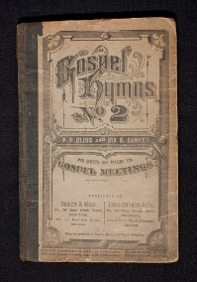  Harriet Tubman hymnbook  Credit Line: Collection of the Smithsonian National Museum of African American History and Culture, Gift of Charles L. Blockson
Themes | Activism, Religion, Slavery, Women’s Rights
Description | Harriet Tubman was a born a slave in Maryland in 1822. After escaping to non-slaveholding Pennsylvania in 1849, Tubman became active in the Underground Railroad – a network of abolitionists and safe houses for escaping slaves – and led at least 13 missions to free around 70 enslaved families. During the Civil War she worked as a spy for the Union, leading a raid in South Carolina that freed 750 slaves. After the war she became active in the movement for women’s suffrage – the right for women to vote.  Tubman drew on the cultural importance of religion as a guide and a tool in her activism. During her life she came to be known as “Moses” in recognition of her work to free slaves. During rescue operations, she sang hymns to signal to the slaves she helped to escape. Tubman’s worn hymnal is both an important personal artifact and a symbol of her life’s work. NMAAHC Founding Director Lonnie Bunch said of the museum’s Tubman artifacts, “There is something both humbling and sacred found in the personal items of such an iconic person.”
Suggested Activities | Music is a powerful social tool and creative outlet. With participants, consider the ways Tubman may have used the songs from this hymnal: to signal, to worship, to bring people together. Ask about the different functions of music in participants’ communities or families. Encourage each participant to present a song or portion of a song (by MP3, YouTube link, or even live performance) that is especially meaningful or important to them.  Lead participants through the “Slave Life and the Underground Railroad: Document Detective” activity (link below). Ask participants to complete the activity in small groups, then encourage participants to share their responses with the entire group.
Conversation Questions | - Why were hymns such a powerful tool for Harriet Tubman? Is music important in your community or home? How is music used in your community?  - Why was religion important to many enslaved people? What role does religion play in bringing together members of your community?  - Why might Harriet Tubman have become involved in women’s suffrage (the right for women to vote) after the end of slavery? Are the struggles for slavery and women’s rights similar?  - Do you have any songs or books that give you inspiration?  - What are other creative forms of expression? Can dance or other non-verbal forms of creative expression still convey meaning?
Resources for more information | “Harriet Tubman’s Hymnal Evokes a Life Devoted to Liberation,” article, Smithsonian Magazine  http://www.smithsonianmag.com/history/harriet-tubmans-hymnal-evokes-life-devoted-liberation-53824293/  “Harriet Tubman,” biography, PBS  http://www.pbs.org/wgbh/aia/part4/4p1535.html  “Our Story: Slave Life and the Underground Railroad: Document Detective,” education guide, National Museum of American History  http://amhistory.si.edu/ourstory/pdf/slavelife/slave_detective.pdf
Video resources | “What You Never Knew About Harriet Tubman,” video, 2:52, Smithsonian Channel  http://www.smithsonianmag.com/videos/category/history/what-you-never-knew-about-harriet-tubman/

Object Name and Image | 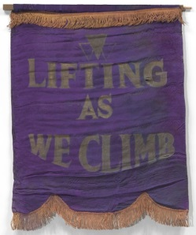  Banner with motto of Oklahoma Federation of Colored Women's Clubs  Credit Line: Collection of the Smithsonian National Museum of African American History and Culture
Themes | Activism, Civil Rights, Civic Engagement, Women’s Rights, Inclusion
Description | This purple silk banner from 1924 bears the motto of the Oklahoma Federation of Colored Women’s Clubs, itself a part of the National Association of Colored Women’s Clubs (NACWC). Between 1896 and 1916, over 300 colored women’s clubs sprang up around the United States, with a combined membership of nearly 100,000. Members aimed to uphold the respectability of black women by acting as positive role models while working to improve life for poor African Americans.  Colored Women’s Organizations engaged in social and political action to improve life not only for colored women, but for black men and children as well. They took aim at diverse racial and gender issues. Over the course of their history, Colored Women’s Clubs advocated for temperance, women’s suffrage, voting rights for black men, and campaigned against lynching, poll taxes, and segregation. The motto emblazoned on this banner, “Lifting as we Climb,” perfectly captures the NACWC’s mission to improve the lives and social position of all African Americans.
Suggested Activities | Have participants make their own slogan banners, similar to the “Lifting As We Climb” banner. Encourage them to think about a slogan that represents an important value or cause in their community or school, and to set and decorate it on a paper or cloth banner. Participants can present their banners to the group for additional English language learning.
Conversation Questions | - What does the phrase “Lifting As We Climb” mean? What are some other ways to express this message?  - What is a slogan? What do they do? Can you think of any slogans from a commercial or advertisement? Does your community or school have a slogan or motto?  - What is a community organization? Why were community organizations important in the Civil Rights Movement?  - How were the African American Civil Rights struggle and campaigns for women’s rights similar? How were they different?  - Why might a women’s organization advocate for men’s rights, too?  - What are some local community organizations you are involved with? Why do you participate?
Resources for more information | “About Us,” article, National Association of Colored Women’s Clubs  http://nacwc.org/aboutus/index.html  “The Rise and Fall of Jim Crow,” article, PBS  http://www.pbs.org/wnet/jimcrow/stories_org_nacw.html  “Separate Is Not Equal,” online exhibition, National Museum of American History http://americanhistory.si.edu/brown/index.html

Object Name and Image Preview | 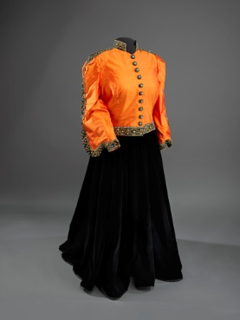  Marian Anderson Ensemble  Credit Line: Collection of the Smithsonian National Museum of African American History and Culture, Gift of Ginette DePreist in memory of James DePreist
Themes | Activism, U.S. Culture, Women’s Rights, Civil Rights, Equality
Description | In 1939, African American concert singer Marian Anderson was the third-highest box office draw in the United States, and had performed before royalty in Europe. Yet at home in the United States, Anderson still faced racial discrimination under Jim Crow laws. Howard University, the historically black college in Washington, DC, hoped to sponsor an Anderson concert at the Daughters of the American Revolution’s Constitution Hall. But keeping their segregationist policy, the Daughters of the American Revolution refused to host Anderson. First Lady Eleanor Roosevelt lent Anderson her support by publicly surrendering her DAR membership, writing, “You had the opportunity to lead in an enlightened way, and it seems to me that your organization has failed.”  In response to the rejection, NAACP secretary Walter White and Secretary of the Interior Harold Ickes arranged for Anderson to give a concert on the steps of the Lincoln Memorial, on Easter Sunday, April 9, 1939. 75,000 people attended, and Anderson celebrated freedom, justice, and equality through her music.  Anderson wore this rich and stately ensemble, made of orange Shantung silk and black velvet, at the performance. Following the famous concert, Anderson became the first African American to perform at the White House. At NMAAHC, Marian Anderson’s dress illustrates and commemorates her artistic success, and a pivotal moment in the struggle for civil rights.
Conversation Questions | - Look up the lyrics of “My Country ‘Tis of Thee” and watch the video clip provided below. Why do you think Marian Anderson choose to sing this song? What did the song symbolize?  - Why did the Daughters of the American Revolution not allow Anderson to perform there? Why might Eleanor Roosevelt and the Secretary of the Interior have supported Anderson?  - Why was the concert an important event? Why was it important in the Civil Rights Movement?  - Do you know of any examples where an artist has been banned? Why were they banned? Is it fair to ban artists or artistic expression?  - Why do you think Eleanor Roosevelt stood up for Anderson? Have you ever stood up for someone who was treated unfairly?
Resources for more information | “Marian Anderson: Freedom Singer and Mentor to Generations,” article, Smithsonian Magazine  http://www.smithsonianmag.com/smithsonian-institution/marian-anderson-freedom-singer-and-mentor-to-generations-111827639/
Video Resources | “Marian Anderson Sings at Lincoln Memorial,” video, 1:19, Robert H. Jackson Center  https://www.youtube.com/watch?v=mAONYTMf2pk  “Smithsonian Spotlight: Marian Anderson in Concert,” video, 1:12, Smithsonian Channel  https://www.youtube.com/watch?v=HEFeoS0tn68

Object Name and Image Preview | 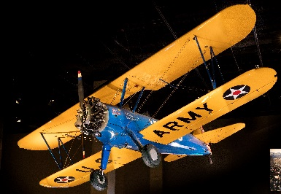  Tuskegee Aircraft  Credit Line: Collection of the Smithsonian National Museum of African American History and Culture
Themes | Segregation, Racism, Inequality, Civil Rights, Aviation
Description | During World War II, the United States mobilized against the Axis powers (Germany, Italy, and Japan), even as many areas of society – including the armed forces – remained segregated. There were no African American military pilots until 1939, when civil rights leaders successfully advocated for African American units of the Army Air Corps. In 1940, the historically black Tuskegee University began training African American pilots, and in 1941 the 99th Pursuit Squadron was formed, becoming the first ever African American air force group. The success of the training program led to more units, and eventually, the 332nd Fighter Group and the 477th Bomber Group became known as the Tuskegee Airmen. Over the course of the war, the Tuskegee Airmen distinguished themselves in missions over North Africa, Italy, and Germany, and gained a reputation as the best pilots in the U.S. military. In all, the Airmen flew 1,578 missions, destroyed 261 enemy aircraft, and were awarded over 850 medals.  The Tuskegee Airmen’s success resulted in a push to end segregation in the armed forces. The group enjoyed public admiration, beginning with First Lady Eleanor Roosevelt’s visit to the Tuskegee training program in 1941. The complex training and staffing needs of such a large program also chipped away at the Army’s strict segregation practices – for example, the Army had no separate facilities for training flight surgeons, so Tuskegee flight surgeons trained in racially integrated courses. After the war, the Tuskegee Airmen’s reputation convinced many officers of the need for integration.  This PT-13D Stearman Kaydet biplane was used as a training aircraft at the Tuskegee Institute. It highlights the importance of flight training as an opportunity for African Americans, and its flashy coloring suggests the high morale and adventurous spirit of the Tuskegee Airmen.
Conversation Questions | - Why was it important for African Americans to join the armed forces? Why was it important for them to gain equal treatment?  - Why might the Tuskegee pilots have wanted to join the military?  - What is equality? Is equality important? What does equality mean to you?  - Why might the Tuskegee Airmen have fought for their country despite training and working in unfair conditions? Have you ever been prevented from doing something you wanted to do because of unfair conditions?  - Why was it so important for the Tuskegee Airmen to be successful?
Resources for more information | “Black Wings: African American Pioneer Aviators,” exhibition website, National Air and Space Museum  https://airandspace.si.edu/explore-and-learn/topics/blackwings/tuskegee.cfm  “Significance of the Tuskegee Airmen National Historic Site,” article, National Park Service  https://www.nps.gov/tuai/learn/historyculture/significance-of-the-tuskegee-airmen-national-historic-site.htm
Video Resources | “The Tuskegee Red-Tail Angels,” video, 2:37, Smithsonian Channel  https://www.youtube.com/watch?v=qMPLpExgkGg

Object Name and Image Preview | 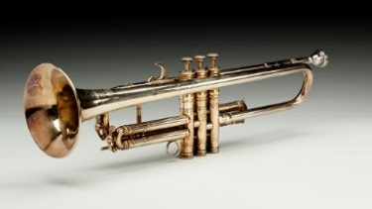  Louis Armstrong’s trumpet  Credit Line: Collection of the Smithsonian National Museum of African American History and Culture
Themes | U.S. Culture, Expression, Tradition
Description | Louis Armstrong, the influential jazz trumpet player, was born in New Orleans in 1901, and started playing a tin horn while working on a junk wagon as a child. He joined Joe “King” Oliver’s jazz ensemble in his teens, and became well-known nationally in 1925. His success continued to grow over the course of a long and memorable career pioneering sophisticated and heartfelt jazz.  Armstrong’s instrument was essential to his identity. “When I pick up that horn, that’s all. The world’s behind me, and I don’t feel no different about that horn now than I did when I was playing in New Orleans. That’s my living and my life,” he wrote in 1957. He owned several individual trumpets over the course of his life – he would typically use a trumpet for about five years, then give it away as a gift.  The French company Henri Selmer made this inscribed B-flat trumpet especially for Armstrong in 1946, after a request from his manager Joe Glaser. The elegant instrument is a symbol of Armstrong’s deep contributions to American music.
Conversation Questions | - How does jazz reflect African American history and culture? How does music reflect history in your community?  - How are personal possessions like this trumpet important to individual identity? How are they important to a community’s identity? What are some objects that are important to your family or community?  - Do you like jazz? What do you like about it? How does it make you feel?  - What does Louis Armstrong’s music tell you? How can music communicate ideas? Do you ever communicate through music or other creative outlets?
Resources for more information | “Louis Armstrong: A Cultural Legacy,” article and images, National Portrait Gallery  http://www.npg.si.edu/exh/armstrong/  “To Really Appreciate Louis Armstrong’s Trumpet, You Gotta Play It. Just Ask Wynton Marsalis,” article and video, Smithsonian Magazine  http://www.smithsonianmag.com/smithsonian-institution/to-really-appreciate-louis-armstrongs-trumpet-you-gotta-play-it-180959184/  “Louis’ Education Kit,” education package and audio files, National Museum of American History  http://americanhistory.si.edu/smithsonian-jazz/education/louis-education-kit

Object Name and Image Preview | 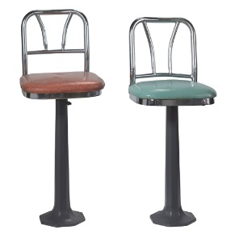  Lunch counter stools from Greensboro sit-in  Credit Line: Collection of the Smithsonian National Museum of African American History and Culture, Donated by the International Civil Rights Center & Museum, Greensboro, NC
Themes | Civil Rights, Racism, Segregation, Equality, Nonviolent Protest, Civic Engagement
Description | In 1960, the policy of the popular lunch counter at Woolworth’s department store in Greensboro, North Carolina, was to refuse all service to African Americans. On February 1 of that year, four black freshmen at the Agricultural and Technical College of North Carolina took seats at the counter and refused to leave until they were served. The men, Franklin McCain, Ezell Blair Jr., Joseph McNeil, and David Richmond, were fed up with being denied services granted to others in the segregated South, and planned to continue their protest until the lunch counter was desegregated. Their sit-in quickly attracted national attention, and inspired African Americans across the country to lead new sit-in protests against segregation. Over the following months African American protestors lined up in the Greensboro Woolworth’s to take their turn at the seats, facing the anger, and sometimes violence, of white segregationists. After six months of continual protest, Woolworth’s gave into public pressure and desegregated their lunch counter. These seats tell of personal strength and the success of nonviolent protest in the Civil Rights Movement.
Suggested Activities | Watch the video “Restaging the Greensboro Counter Sit-In” (link below). With the group, make a list of strategies for nonviolent protest mentioned in the video. Discuss why these strategies were effective, and the challenge and importance of remaining nonviolent. If appropriate, consider incorporating current events, local or otherwise, into the discussion as examples of nonviolent protest.
Conversation  Questions | - What is segregation? Why did the students in Greensboro want to protest segregation?  - Why was segregation of public spaces wrong? What are some other examples of segregation from the Civil Rights era?  - What is a sit-in? Why do you think the students chose this form of protest? How were sit-ins an effective form of protest?  - Do you think the four students were courageous for their nonviolent actions? What does courage mean to you? Describe a time you were courageous.  - What did this sit-in change? Do you think the actions of the students in Greensboro had an effect on people outside of North Carolina?
Resources for more information | “Courage at the Greensboro Lunch Counter,” article, Smithsonian Magazine  http://www.smithsonianmag.com/arts-culture/courage-at-the-greensboro-lunch-counter-4507661/?all  “Separate Is Not Equal: Freedom Struggle,” online exhibition, National Museum of American History  http://americanhistory.si.edu/brown/history/6-legacy/freedom-struggle-2.html  “Greensboro Lunch Counter Sit-In,” online resource, Library of Congress. http://www.loc.gov/exhibits/odyssey/educate/lunch.html#mainidea
Video Resources | “Restaging the Greensboro Counter Sit-In,” video, 5:03, Smithsonian Magazine  https://www.youtube.com/watch?v=TWlKK2HvD-8
Object Name and Image Preview |  |  | 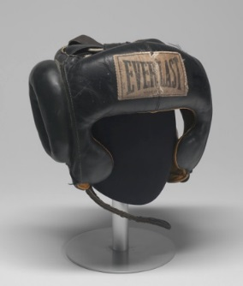  Muhammad Ali’s Headgear  Credit Line: Collection of the Smithsonian National Museum of African American History and Culture
Themes |  |  | Arts and Culture, Sports, Social Engagement, Freedom of Religion
Description |  |  | Muhammad Ali was born Cassius Clay in Louisville, Kentucky. He began to train as a boxer when he was 12 years old, and at 18 he won the gold medal in the light heavyweight division at the 1960 Rome Olympics. He shot to national fame in 1964, when he won the world heavyweight title from Sonny Liston in a shocking upset. Over the course of his career, Ali became the only three-time lineal heavyweight champion, taking the title in 1964, 1974, and 1978.  Ali’s dominant fighting style and brash public manner matched his outspoken political views. In the early 1960s, he became a Muslim and joined the Nation of Islam under the mentorship of Malcolm X, changing his name from Cassius Clay to Muhammad Ali. His conversion and belief in black separatism upset many white fans, and some sports reporters refused to call him by his new Muslim name. In 1966, he was drafted into the U.S. Army for service in the Vietnam War, but refused to join, considering himself a conscientious objector – he did not agree with the Vietnam War and compared it to racial injustice at home. He was promptly arrested and stripped of his boxing titles.  The supreme court overturned his conviction in 1971, after public opinion had turned against the War, but by the time he regained a boxing license in 1970 he had lost five years of his athletic prime. Nevertheless, he came back to win the heavyweight titles in 1974 and 1978.  Ali wore this protective headgear during his training at the 5th Street Gym in Miami, Florida in the early 1960s. A mix of people of different races, politics, and religions trained at the 5th Street Gym, and it was during this period that Ali’s political consciousness grew. This headgear is a symbol of Muhammad Ali’s hard work and dedication, as well as of his political formation.
Conversation Questions |  |  | - Why do you think Muhammad Ali converted to Islam?  - Did Muhammad Ali face discrimination because of his religion? How did he overcome it?  - What does religion mean to you? Have you ever faced discrimination because of your religion?  - Do you play or watch sports? How can sports help individuals develop skills and confidence?  - Muhammad Ali was politically outspoken. Do you think athletes should speak out about politics? Are there athletes or other figures in popular culture, locally or in the U.S., who speak out about their beliefs?
Resources for more information |  |  | “Float Like a Butterfly: In Memory of Muhammad Ali,” article, National Museum of African American History and Culture  https://nmaahc.si.edu/explore/stories/collection/float-butterfly  “Muhammad Ali (1942-2016),” article and primary sources, Smithsonian Insider  http://insider.si.edu/2016/06/muhammad-ali-1942-2016/
Video Resources |  |  | “Did Muhammad Ali Throw His Gold Medal Into the Ohio River?” video, 1:49, Smithsonian Channel  https://www.youtube.com/watch?v=y5BsetX1JTk&feature=youtu.be
Object Name and Image Preview | 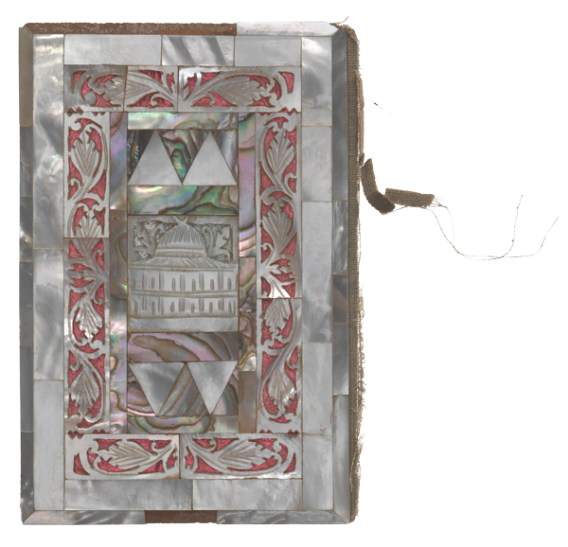  Koran Owned by Elijah Muhammad  Credit Line: Collection of the Smithsonian National Museum of African American History and Culture, Donated by Halimah Mohammed Ali, granddaughter of the Hon. Elijah Mohammad and Clara Muhammad
Themes | Freedom of Religion, Civil Rights, Arts and Culture, Social Engagement
Description | Elijah Muhammad, the influential leader of the Nation of Islam, was born Elijah Poole in Sandersville, Georgia in 1897. His parents were poor sharecroppers, and Elijah left school after the third grade to help support his family. He claimed to have witnessed three lynchings of black men by the age of twenty, and his experiences with racism in Georgia left him painfully aware of racial injustice in America. In 1923, the Poole family moved to Detroit, where Elijah worked in an auto factory. In 1930 he attended a lecture by Wallace Fard, the charismatic founder and leader of the Nation of Islam. He joined the movement and adopted the Muslim name Elijah Muhammad. He quickly became leader of the movement in Detroit, and took over leadership of the entire Nation after Fard’s disappearance in 1934.  During the decades of Muhammad’s leadership, the Nation of Islam grew into a national religious movement that owned stores, restaurants, and barbershops, and boasted such prominent members as Malcolm X, Louis Farrakhan, and Muhammad Ali. The movement struck a chord with many African Americans because it preached clean living, self-reliance, and self-defense. Elijah Muhammad preached that Islam was the natural religion and culture of African Americans, and that by converting to Islam they could recover the culture that had been stolen from them during slavery. Many saw the Nation of Islam as an alternative to the Christian communities that traditionally dominated African American life.  This ornate Koran was both a tool and a symbol for Elijah Muhammad. Like many Korans across the Muslim world, it is beautifully decorated to honor its sacred contents. The cover is inlaid with silver and mother-of-pearl, and presents geometric and floral patterns that center on a design of a mosque.
Conversation Questions | - Why do you think Elijah Poole took a new name when he converted to Islam? What does it mean to change your name?  - What does “self-reliance” mean? Are there moments in your life when you have been self-reliant?  - Why do you think the Nation of Islam was attractive to many African Americans?  - How did the religious principles of Islam guide his movement? Are there religious political movements in your country?  - Do politics and religion overlap in your life?  - Describe the decoration on the ornate cover of the Koran. What does the decoration, including the materials, tell you about the significance of these texts?
Resources for more information | “Islam in America,” article, PBS  http://www.pbs.org/opb/historydetectives/feature/islam-in-america/  “Elijah Muhammad and the Nation of Islam,” article, PBS  http://www.pbs.org/wgbh/amex/malcolmx/peopleevents/e_noi.html  “The Art of the Qur’an: Treasures form the Museum of Turkish and Islamic Arts,” exhibition website, Smithsonian’s Freer|Sackler Galleries  http://www.asia.si.edu/exhibitions/current/art-of-the-quran/overview.php  “The Art of the Qur’an: Educator Resource Page,” classroom resources, Smithsonian’s Freer|Sackler Galleries  http://www.asia.si.edu/exhibitions/current/art-of-the-quran/educators.php
Object Name |  | 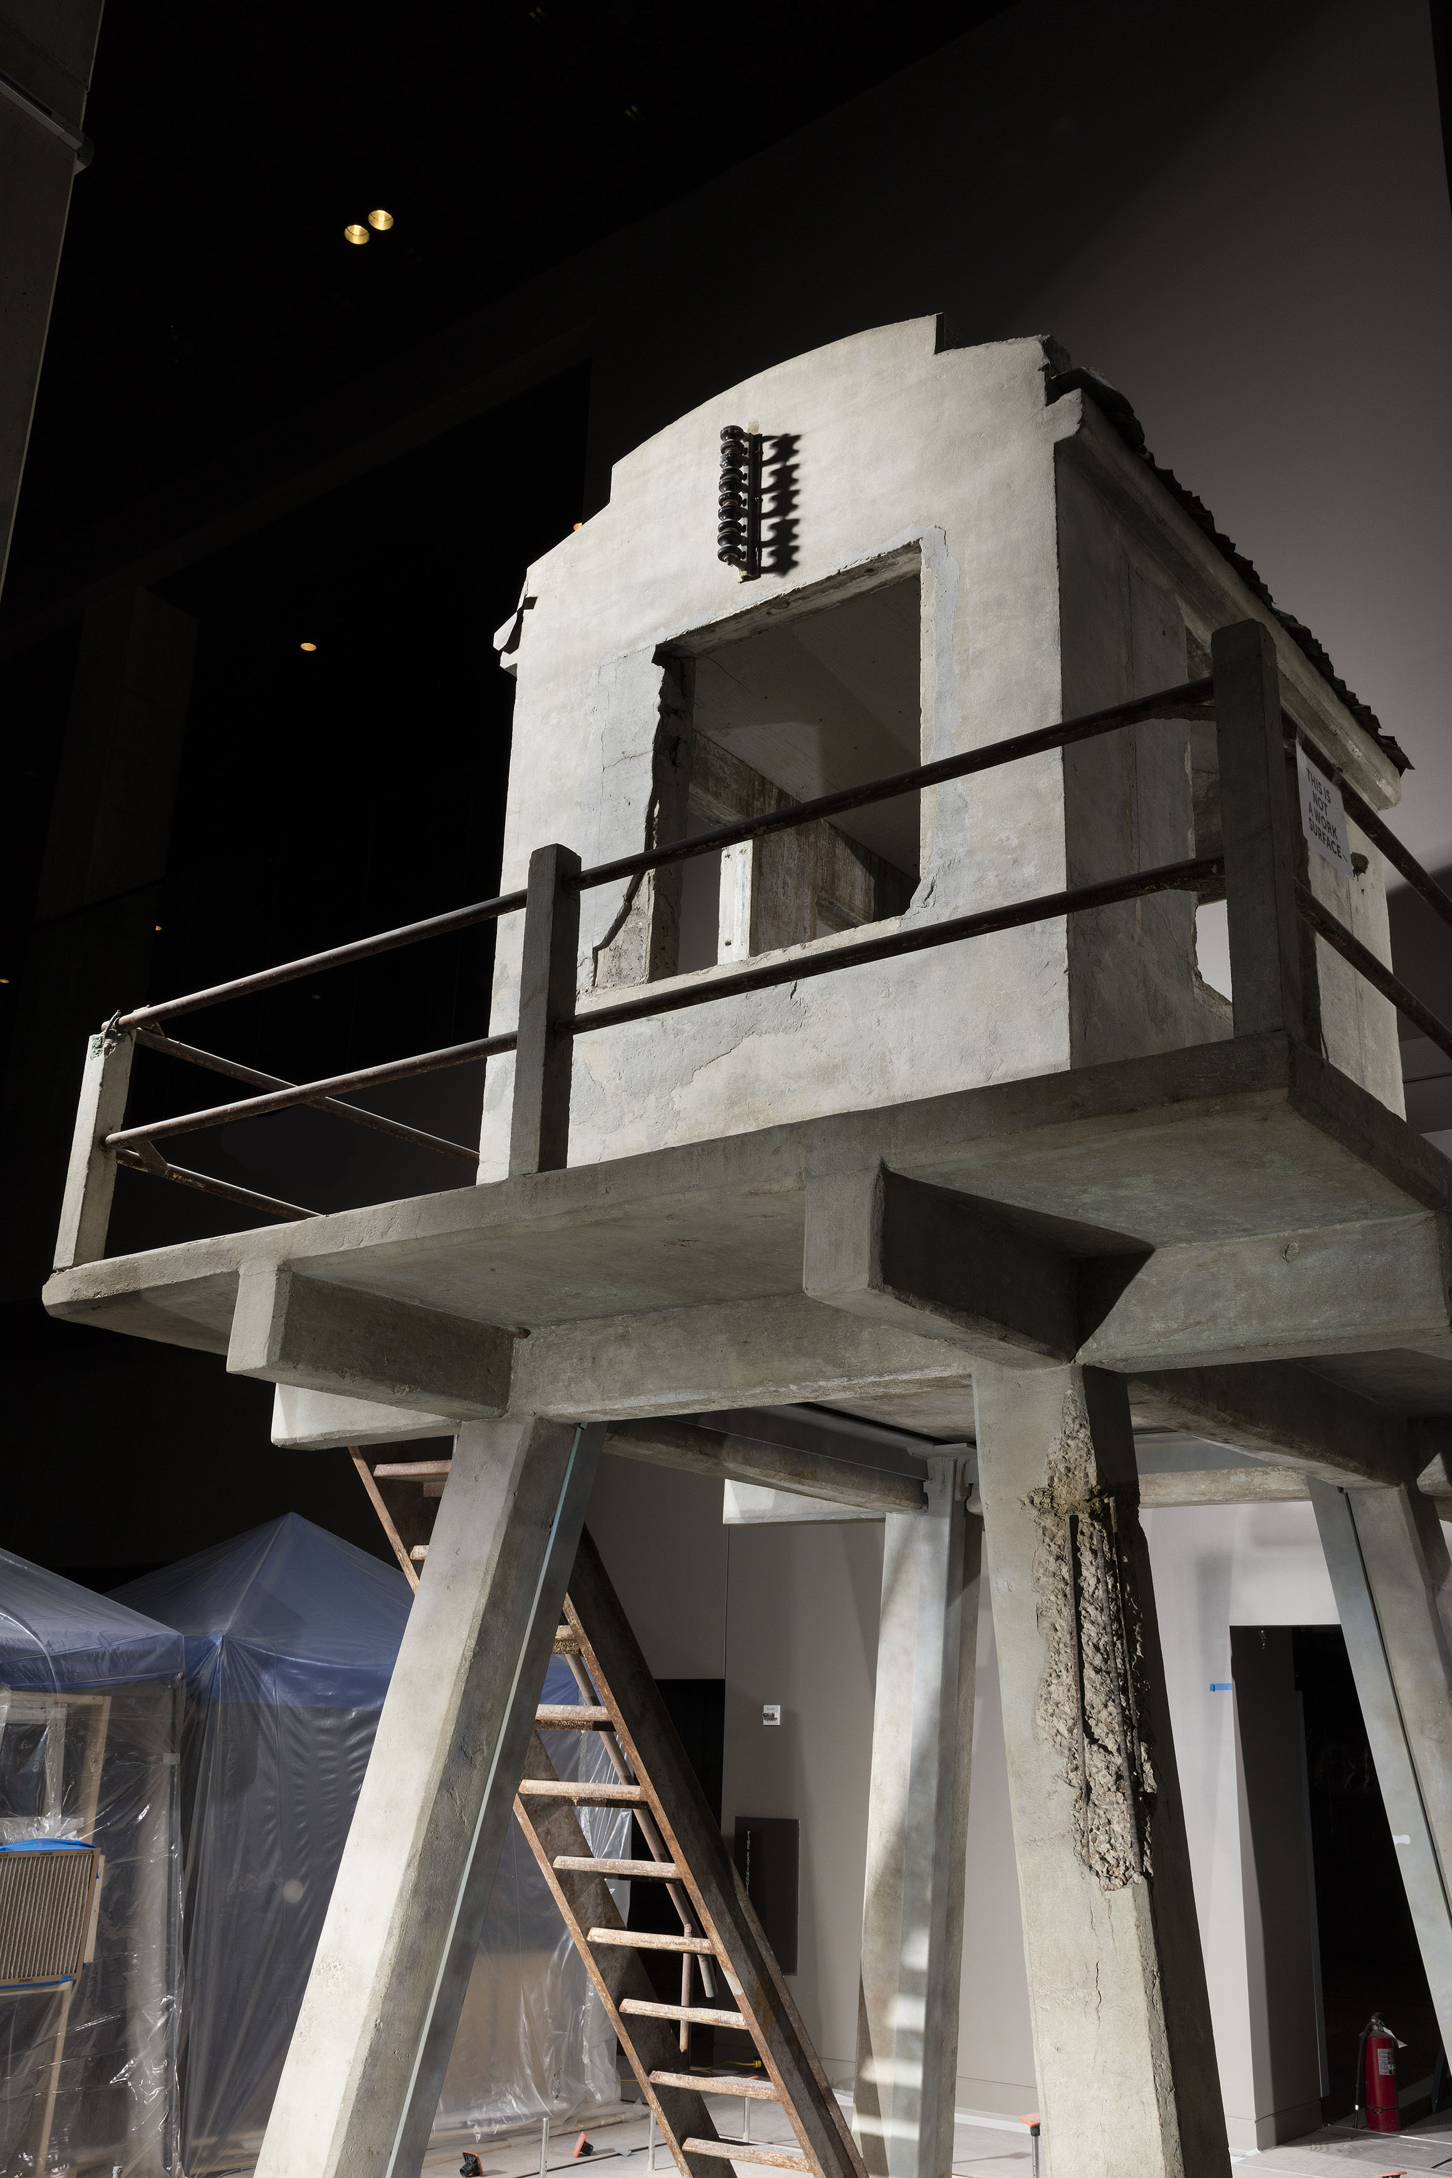  Guard tower from Angola Prison  Credit Line: Collection of the Smithsonian National Museum of African American History and Culture, Donated by Louisiana Department of Public Safety and Corrections and Louisiana State Penitentiary at Angola
Themes |  | Civil Rights, Racism, Slavery
Description |  | Louisiana State Penitentiary, known as Angola Prison, is one of the largest maximum-security prisons in the United States. It is built on the site of a former slave plantation about 160 kilometers north of New Orleans—the name Angola is thought to come from the origins of many of the slaves there. Former Confederate Major Samuel James leased the site in 1880 to house the state’s growing population of prisoners, whose lives in Angola came to mimic the conditions of slavery. Because of discriminatory penal codes, inmates were overwhelmingly African American, and they were forced to work the sprawling prison farm, which for most of its history sold vegetables for profit. Prisoners labored for long hours in scorching weather, and faced violence from guards. The convict lease system allowed private citizens to hire prisoners without paying them. The prison even came to mirror the structure of a slave plantation, with a close-knit community of mostly white guards living on prison grounds, and the cell blocks built on the former slave quarters.  During the 20th century, Angola became notorious for its harsh conditions, including high rates of inmate violence. The prison became a flashpoint for civil rights debates in the second half of the century. Although Angola has reformed since 1995, curbing violence and introducing a reformatory approach, the prison remains a stark symbol of the disproportionate, mass imprisonment of African Americans. Today, 80 percent of Angola’s prisoners are African American, and 75 percent are serving life sentences.  The imposing guard tower represents the tumultuous history of Angola and the surveillance and control of African Americans, drawing a line from slavery to the injustices of the present day.
Conversation Questions |  | - Do you think the history of slavery and its location shaped Angola Prison? Is Angola Prison like a slave plantation today?  - Why did Angola Prison become a crossroads for civil rights debates?  - In recent years, Angola Prison has been reformed. Do you think it is important to remember its violent history? How can we remember histories like this productively?  - How does understanding history help us understand current events? How does history help you understand your own community?
Resources for more information |  | “The ‘Legacy of Slavery’ Comes to the Smithsonian with Angola Prison Guard Tower Donation,” article, Smithsonian Magazine  http://www.smithsonianmag.com/smithsonian-institution/the-legacy-of-slavery-comes-to-the-smithsonian-with-angola-prison-guard-tower-donation-9044170/  “Why Mass Incarceration Defines Us as a Society,” article, Smithsonian Magazine  http://www.smithsonianmag.com/people-places/why-mass-incarceration-defines-us-as-a-society-135793245/
Video Resources |  | “Angola for Life,” video, 13:17, Atlantic  https://www.theatlantic.com/video/index/404305/angola-prison-documentary/

Object Name | 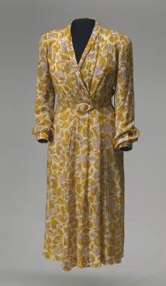  Rosa Parks’ Dress  Credit Line: Collection of the Smithsonian National Museum of African American History and Culture, Gift of the Black Fashion Museum founded by Lois K. Alexander-Lane
Themes | Activism, U.S. History and Culture, Civil Rights, Segregation, Women’s Empowerment
Description | Rosa Parks is known for refusing to give up her seat at the front of a segregated bus in Montgomery, Alabama, a simple gesture that launched a 382-day bus boycott. Though Parks’ defiance of segregation was a courageous act, it was also part of a coordinated campaign for civil rights in Montgomery. Parks was the longtime secretary of the Montgomery National Association for the Advancement of Colored People (NAACP), and campaigned for African American voting rights, justice for racial violence, and an end to segregation. After her famous protest, civil rights leaders championed her case and turned her into an icon of the Civil Rights Movement.  In her everyday life, Parks worked as a seamstress at the Montgomery Fair department store. At the time of her arrest on December 1, 1955, she was making this rayon georgette print dress for her own wardrobe. The dress is a symbol of Parks’ personal life and expression, but also a reminder of the price she paid for her protest: after her arrest, she was fired from her job as a seamstress. The dress is a reminder of the fortitude and courage of ordinary African Americans that built the Civil Rights Movement.
Conversation Questions | - What is segregation? Why do you think Rosa Parks stood up against it?  - Why did Rosa Parks refuse to give up her seat on the bus? What did her nonviolent protest achieve? Why was it important?  - Do you think Rosa Parks’ decision was spontaneous? Do you think it was planned? Why does it matter?  - Why did Rosa Parks lose her job? Do you think she thought she might lose her job?  - What is a sacrifice? Describe a time when you have had to make a sacrifice to stand up for what is right or fair.  - Why was Rosa Parks’ action important? Why do you think it got national and international attention? How can individual actions help fight larger injustices?  - The Civil Rights movement relied on advocacy efforts by individuals and groups. Do you think individuals have the power to create change?  - Why was Rosa Parks’ protest effective? How is it an example of nonviolent protest? Can you think of other relevant examples where nonviolent protest has been successful in the U.S. or in your community?
Resources for more information | “Get Reintroduced to Rosa Parks as a New Archive Reveals the Woman Behind the Boycott,” article, Smithsonian Magazine  http://www.smithsonianmag.com/history/reintroduced-rosa-parks-new-archive-reveals-woman-behind-boycott-180957200/  “Rosa Parks: Tired of Giving In,” blog post, National Portrait Gallery  http://npg.si.edu/blog/tired-giving

