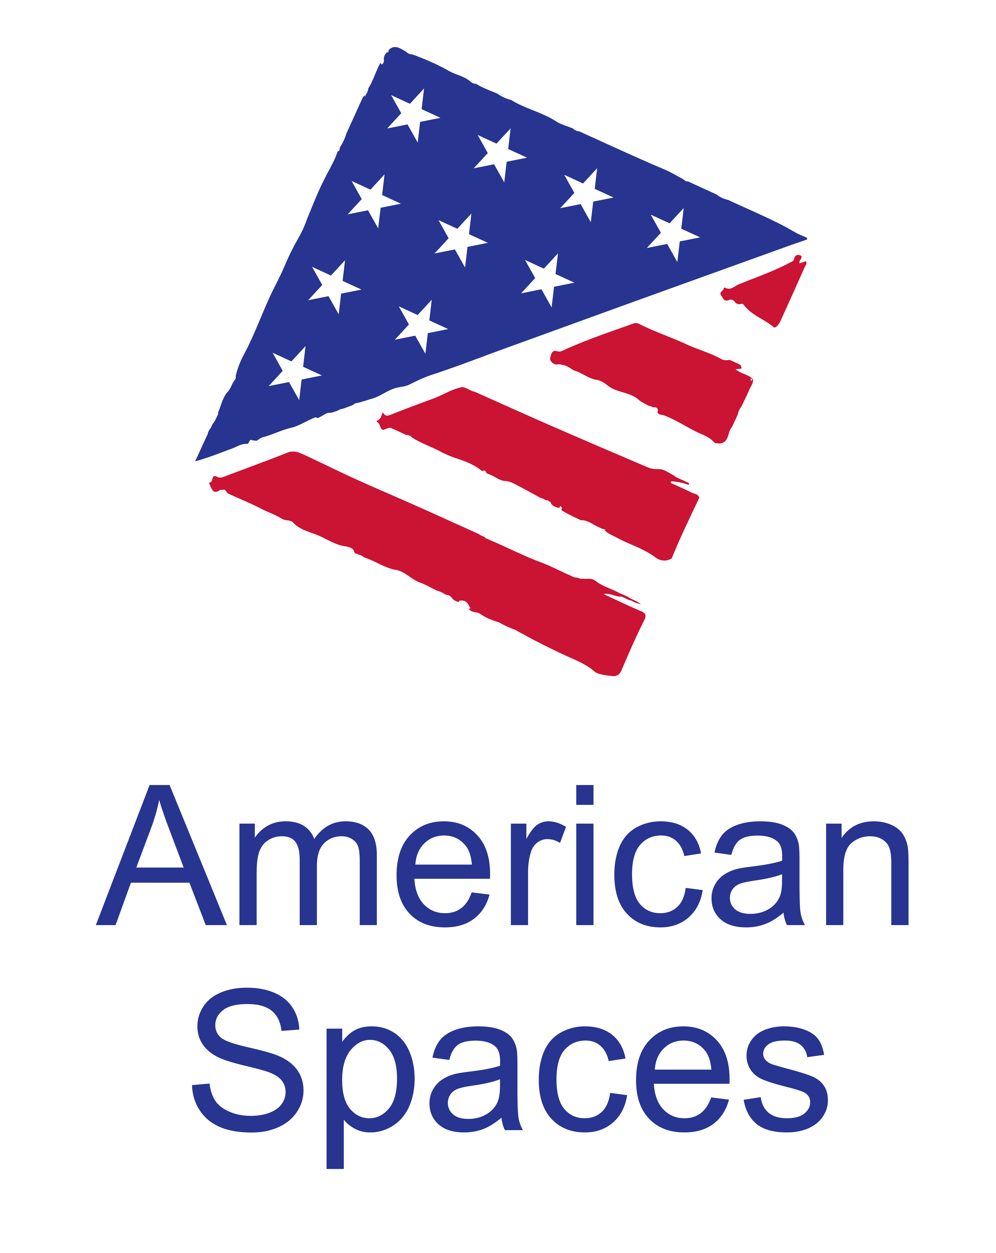
American Spaces Programming Resources

Native American Indian and Alaska Native Heritage

Please note:
The resources provided here are not required programs. The Office of American Spaces recommends collaborating with the U.S. Embassy’s or Consulate’s Public Affairs Section on the programs offered in American Spaces.

National American Indian and Alaska Native Heritage Month is celebrated every November to recognize the intertribal cultures and to educate the public about the heritage, history, art and traditions of the American Indian and Alaska Native people.

Programming Resources
- Native Knowledge 360: Framework for Essential Understandings about American Indians -- https://americanindian.si.edu/nk360/
  - A National Education Initiative between Smithsonian’s National Museum of the American Indian (NMAI) and Native communities and educators
    - Under Lessons and Resources, 4 digital lessons offered on:
      - Pacific Northwest History and Cultures: Why Do the Foods We Eat Matter?
      - The Pacific Northwest Fish Wars: What Kinds of Actions Can Lead to Justice?
      - Northern Plans History and Cultures: How Do Native People and Nations Experience Belonging?
      - Northern Plains Treaties: Is a Treaty Intended to Be Forever?
    - Digital Lessons include online lessons, videos, audio clips, student worksheets, and more
    - Variety of resources allows for multiple programs ranging from 45 – 90 minutes each
- Teacher Resources from US government and partner institutions -- https://nativeamericanheritagemonth.gov/for-teachers/
  - Educator resources from Library of Congress, National Archives, National Endowment for the Humanities, National Gallery of Art, National Park Service, and the Smithsonian Institution

Possible Film/Video Screenings
- Film: Our Fires Still Burn
  - Film is free on Kanopy (through e-LibraryUSA)
  - 1 hour – Documentary invites viewers into the lives of contemporary Native American role models living in the Midwestern United States
  - Movie Programming Kit (accessible here: https://americanspaces-state.edit.usembassy.gov/wp-content/uploads/sites/292/Our-Fires-Still-Burn_Movie-Kit-Kanopy_FINAL.pdf)

- Film: Smoke Signals
  - Movie is covered under MPLC agreement; PG-13; Post will need to procure film on own
  - 1 hour 29 mins – The film is unique as an all-Native American production, where two American Indian teenagers go on a journey and learn more about their cultural identity.
  - Movie Programming Kit (accessible here: https://americanspaces-state.edit.usembassy.gov/wp-content/uploads/sites/292/Smoke-Signals-Movie-Kit_v2.pdf)

Suggested Movies Covered Under MPLC Licensing Agreement
- https://americanspaces.state.gov/programming/the-motion-picture-licensing-corporation-agreement/)
- Visit the Managing American Spaces website to find suggested movies covered by the Motion Picture Licensing Corporation (MPLC) agreement that may be shown as part of Native American Indian and Alaska Native Heritage Month. For a listing of ECA-suggested film titles:
- Under the first FAQ (Suggested Film Titles by Category/Genre/Theme), click on “list of film titles (xlsx 748)”
- On the bottom of the spreadsheet, scroll to the tab “Native American Stories”
- Note: The inclusion of each title represents a suggested and/or potentially relevant film, not an endorsement. All posts/Spaces are advised to preview film titles privately before public screenings to ensure that all thematic material and content is culturally and programmatically appropriate for their intended audiences.
- Posts will need to procure films on own.

eShop Collections
*eShop collections include a selection of products, including books, games, posters, kits, etc, on specific topics that may be used for programs to engage target audiences.
- American Indians and Alaska Natives -- https://eshop.state.gov/Americans/American%20Indians%20&%20Alaska%20Natives
  - Consider hosting a Book Club event with one of the books in this collection.

Written/Photo/Video Resources
- Share America article – 21st Century Native Americans tell their stories -- https://share.america.gov/21st-century-native-americans-tell-their-stories/
- Share America article – Words and Names that come from Native Americans -- https://share.america.gov/words-and-names-that-come-from-native-americans/
- Share America article – Native American fashion now – pushing boundaries -- https://share.america.gov/native-american-fashion-now-pushing-boundaries/
- IIP Photo Archive – National American Indian and Alaska Native Heritage Month: https://www.flickr.com/photos/iip-photo-archive/sets/72157688749851184

Additional Background Resources
- White House Proclamation: https://www.whitehouse.gov/presidential-actions/president-donald-j-trump-proclaims-november-2017-national-native-american-heritage-month/
- Native American Indian Facts: https://native-american-indian-facts.com/
- Scholastic -- An Overview of Native American History: https://www.scholastic.com/teachers/articles/teaching-content/history-native-americans/
- Youtube – November Native American Heritage Month (slideshow featuring Native American images and chants; 8 min 6 secs): https://www.youtube.com/watch?v=eNEr-ZDfVOY

