Expressing Freedom
THEMES: Rights, civil society, civic engagement, nonviolent protest, freedom of expression, U.S. history, and democracy
SUMMARY: This program encourages participants to reflect on the rights they have and how they can advocate for their own rights and the rights of others. Participants will (1) analyze three objects from the Smithsonian National Museum of American History relating to the history of civil rights and (2) use them as inspiration to create an object and message that expresses their own rights and freedoms.
The program includes three high-quality photographs of museum objects and three archival photographs. Information about these images, including a link to download them from the American Spaces website, can be found on page 5 of this packet.
LESSON SNAPSHOT:
TIME | SKILLS | TECHNOLOGY | MATERIALS | PROJECT
1 – 1.5 hours | Creative design, self-expression, analytical thinking | A computer and projector or digital monitor to display images to the group are optional, but recommended.  Computers with graphic design software, such as Photoshop or Lightroom* are also optional for the design activity. | Provided in this packet: All instructions for leading analysis and hands-on design activities; high-quality images (linked); optional image handouts.  Additional materials needed: A whiteboard or writing surface. A variety of art materials for a hands-on activity. Materials could include construction paper, cardboard, colored pencils, pens, markers, scissors, glue, tape, and more.  Optional: computers with design software, printers, a button-making machine, etc. | Participants will use observation and analysis skills to discuss objects from U.S. history and then take inspiration from those objects to create their own object and message that expresses their rights.
*Please note these software examples are intended to provide ideas for facilitating your program. The Smithsonian Institution did not create the software listed and does not specifically endorse these products or services.

LESSON OVERVIEW:
LESSON OUTCOMES | Participants will:  - Explain the rights they have and the rights they value.  - List some examples from U.S. history in which people expressed and advocated for their rights.  - Reflect on why they should express and advocate for their own rights and those of other people.  - Create their own object to express awareness and appreciation for their rights and the rights of others.
FACILITATOR PREPARATION | The facilitator should spend time reviewing the contents of this packet to become familiar with the material, especially with the history of the three objects included here.  The facilitator may also choose to spend time reviewing the U.S. Bill of Rights and the UN Universal Declaration of Human Rights. Please also see Vocabulary and Additional Resources below for more context and information. The facilitator can choose to review these ahead of the program or even provide them for participants to read before, during, or after the program.  Gather all the materials you will need, including a computer (optional), projector (optional), and any craft materials available, before the program.
VOCABULARY | - Advocate:  - (noun) a person who supports or promotes the interests of a cause or group  - (verb) to support or argue for a cause  - Amendment: the process of altering a law or document (such as the U.S. Constitution). The U.S. Bill of Rights (1791) is made up of 10 Amendments  - Discrimination: the unjust or prejudicial treatment of a person or group, especially on the grounds of race, gender, or sexual orientation  - Enfranchisement: the giving of a right or privilege, especially the right to vote  - Red Tape: official routine or procedure marked by excessive complexity, often resulting in delay or inaction  - Suffrage: the right to vote in political elections
ADDITIONAL RESOURCES  Smithsonian resources intended to provide additional information, context, and background of themes in this lesson | - “The Confusing and At-Times Counterproductive 1980s Response to the AIDS Epidemic”: http://www.smithsonianmag.com/history/the-confusing-and-at-times-counterproductive-1980s-response-to-the-aids-epidemic-180948611/  - “Finding Lessons for Today’s Protests in the History of Political Activism”: http://www.smithsonianmag.com/smithsonian-institution/finding-lessons-todays-protests-history-political-activism-180961309/  - “The Original Women’s March on Washington and the Suffragists Who Paved the Way”: http://www.smithsonianmag.com/history/original-womens-march-washington-and-suffragists-who-paved-way-180961869/

DETAILED LESSON PLAN:
1. Introduction to Rights: Introduce rights, and ask participants to consider their own rights.  (10 -15 minutes) | - Explain briefly that rights are freedoms and entitlements that all human beings have. You can have the right to be treated a certain way, or the right to participate in government activities. Ask participants to name the rights they have, or any rights they can think of, and write their responses up on a board, easel, or elsewhere they can see them and refer back to them.  If nobody mentions them, you may wish to highlight and define:  - Right to participate in government: You have the right to be involved in your own government, whether by voting or running for public office.  - Freedom from enduring discriminatory behavior of others: You have the right to be treated equally, and may not be discriminated against on the basis of origin, race, sex, age, sexual orientation, religion, cultural identity, or other characteristics.  - Freedom of expression: You have the right to express your thoughts and ideas in public, without fear of persecution.  Note: This may vary from country to country, so you can use the United States for this example if most appropriate.  - Ask participants to write down three rights that are important to them personally and hold onto their list. These rights could be drawn from the brainstormed list or created by the participant.  - Ask participants why they think it is essential to be aware of and advocate for your rights and the rights of others. Examples include:  - If you are not aware of your rights, or if you do not express them, they can be taken away more easily.  - Advocating for the rights of “others’” does not have to be quid pro quo. You advocate for others’ rights because it’s the humane and ethical thing to do to get to a fairer society.  Note: If there are local examples that can be used to illustrate individuals advocating for the rights of a marginalized group, feel free to use any examples here.
2. Know Your Rights: Show and discuss the objects from Smithsonian’s National Museum of American History. Lead participants to consider how people express their rights.  (20 - 25 minutes) | This section focuses on three objects from the Smithsonian’s National Museum of American History: the Woman Suffrage Banner, the Civil Rights March Buttons, and the AIDS Memorial Quilt Patch.  - Display the provided image of each object on a projector, digital monitor, or by printing and hanging the high-resolution images or using the handouts in this packet. (Information about the images, including links to the images on the American Spaces website, is available on page 7 of this packet.) Ask participants questions about each object, without yet providing background information.  - Ask them to describe what they see through a series of guided questions. It is best to ask open-ended questions rather than yes/no questions, but a variety of questions will work to spark discussion. Questions may include: What do you see in this object? What catches your eye? Does it look handmade? Is it colorful?  - Then, ask participants to consider what the object might have been used for. Questions may include: How do you think this object was used? Was it worn, carried, displayed? Where and when do you think it was used?  - Finally, ask: What is the object’s message? How is that message conveyed?  Facilitator Tip: Help participants better understand the messages conveyed in these objects by defining a few vocabulary terms, including:  - Amendment: the process of altering a law or document (such as the U.S. Constitution). The U.S. Bill of Rights (1791) is made up of 10 Amendments.  - Enfranchisement: the giving of a right or privilege, especially the right to vote  - Once participants have discussed these questions, read out or paraphrase the historical information for each object, to provide some context.  Optional: Show the context photo for each object (provided in this packet) on the projector screen.  - Lead a discussion about the rights the object expresses. Begin by asking the following questions:  What right(s) does this object express?  Why is the right being expressed (e.g. Right to Vote, Freedom from Discrimination, Equal Access) important?  Repeat these steps for each object. The context pages in this packet highlight some relevant rights for each object.  Adapt this program:  - If you’re short on time, choose to present just one or two of the objects that resonate with a local question or issue.  - For a larger group, ask participants to go through the questions in step 1 in groups of two or three. Then, reconvene the whole group and complete steps 2 and 3 together.
3. Express Your Rights: Guide participants in an activity to create their own objects to represent an important right.  (20 - 30 minutes) | - Ask participants to think about what they want to express, and how they can use the Smithsonian objects for inspiration.  - Ask participants to return to the rights they wrote down at the beginning of the program, and think about how the Smithsonian objects they have seen and just discussed advocate for or defend different rights. Then, encourage participants to talk briefly with a partner about which rights they chose, and whether their ideas of rights have changed.  - While they discuss amongst themselves, write down the following questions on the board or other writing surface to help participants develop their object concept.  Do you want an object you can wear every day, or one that you can use for special occasions?  What is your message? How will you emphasize your message? Who is your message aimed at? How will you target your audience?  What will your object look like? Will it be flashy or simple?  - Each participant will design and create an object of their own that expresses a right they find personally important. Use the questions on the board to get participants thinking about the right they have selected and the way in which they want to communicate the importance of this right to others. These objects could contain a combination of words, images, or designs to convey or express the rights they have selected. Participants should think about creating a banner, a poster, a button, or another wearable item that clearly conveys their positive message.  - Set out a variety of craft materials at each table while participants are discussing their rights. Materials could include a selection of the following: copy paper, construction paper, poster board, markers, pens, pipe cleaners, scissors, glue, tape, paint, or any other supplies you have available.  - While participants are designing and crafting their objects, walk around the room and talk with them about their creations. You could ask: What rights are you thinking about in your design? Why did you choose this color/shape? Are you going to wear/use this?  - Give participants a five-minute warning before the activity is finished to allow them to put finishing touches on their designs.  Facilitator Tips:  - This activity can be completed with a variety of craft supplies. For a more technologically advanced group of participants, consider conducting this activity using computer design software for digital skill-building opportunities.  - Some participants might have trouble coming up with an object to design. Here are some questions to help them get started:  What issues are important to you? What rights do those issues involve?  Did any of the Smithsonian objects stand out to you? Why did they stand out to you? Would you want to create something similar?
4. Share Out: Participants will present the objects they created to the group  (10 - 20 minutes) | - Ask each participant to show their object to the group, and have other participants talk about what they see. Ask participants two questions about each object:  What rights does this object express? What issues or events does it connect to?  - Then, ask each presenter to explain why they created their object, and what it represents to them. Ask them to respond briefly to three questions:  What inspired you? What is your object’s message? Why is this message important to you?  Adapt this program: For larger groups, ask just three or four volunteers to present.
5. Conclusion: Lead a final discussion on expressing and advocating rights.  (5 minutes) | Lead a brief discussion to emphasize the importance of advocating for rights. Ask participants: Why is it important to express your rights?  Ask participants to reflect on how this workshop has changed their thinking about their own rights and the rights of others. Are you going to use the object you made? Are you willing to express your rights in your everyday life? How can you advocate for your own rights and the rights of others?  Adapt this program: If you’re short on time, choose one or two of these questions to ask.  Extend the lesson (optional): Consider facilitating another program using the Civil Society Certifications ( https://americanspaces.state.gov/home/wp-content/uploads/2017/01/civil-society-certifications-final.pdf) to extend this lesson and the themes discussed here while promoting digital literacy skills.
SMITHSONIAN OBJECT IMAGES AND BACKGROUND INFORMATION:
This program includes six high quality images: three photographs of museum objects, and three corresponding images showing the contexts in which the objects were used.* All images can be found on the American Spaces website, via the following link: https://americanspaces.state.gov/home/programming/expressing-freedom-national-museum-of-american-history-program-package/
*The March on Washington for Jobs and Freedom context photo is best viewed on a projection screen, digital monitor, or printed handout as the image resolution is not intended for large-scale printing for posters.
Object image preview and information:
Woman Suffrage Banner  Date: 1913  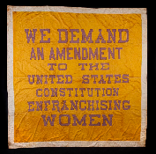  Credit line: Collection of the National Museum of American History | Historical Context: The National Woman Suffrage Procession was an important moment in civil rights for American women. On March 3, 1913, the day before President Woodrow Wilson’s inauguration as the 28th U.S. President, 8,000 women marched in Washington, D.C. for their right to vote. They carried banners like this one, demanding that the Constitution enfranchise women. The march soon turned violent when people attacked the demonstrators, but the violence ultimately won public sympathy for the marchers. Seven years later, in 1920, the 19th Amendment to the Constitution granted women the right to vote.  Relevant Rights: Right to Vote, Freedom from Discrimination, Participation in Government, Freedom of Assembly  More Information: “Suffragette City: The March that Made and Changed History in D.C. Turns 100.” Leah Binkovitz, Smithsonian Magazine, February 28, 2013. Article.  http://www.smithsonianmag.com/smithsonian-institution/suffragette-city-that-march-that-made-and-changed-history-in-dc-turns-100-29494835/
Civil Rights Buttons  Date: 1963  Credit Line: Collection of the National Museum of American History | Historical Context: During the 1960s, the racism and discrimination that African Americans across the United States faced was particularly severe and disturbing. On August 28, 1963, hundreds of thousands of people marched on Washington, D.C. to protest discrimination and support civil rights for African Americans. The March on Washington for Jobs and Freedom brought 250,000 people to the National Mall, where Dr. Martin Luther King, Jr. gave his famous “I Have A Dream” speech. Marchers wore buttons like these to express their support and solidarity.  Relevant Rights: Right to Vote, Freedom from Discrimination, Equality of Access, Participation in Government, Freedom of Assembly, Equal Protection of the Law  More Information: “Remembering the March on Washington.” Bart Nason and Bryan R. Reed, Smithsonian.com. Video, 08:36.  http://www.smithsonianmag.com/videos/category/history/remembering-the-march-on-washington/
AIDS Memorial Quilt Panel  Date: 1987  Credit Line: In memory of Roger Lyon, Division of Medicine & Science, National Museum of American History  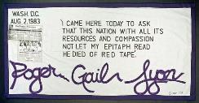 | Historical Context: The AIDS Memorial Quilt is an enormous collection of individual patches, each one celebrating the life of someone who died of AIDS. When AIDS first emerged in the late 1970s and 1980s, it was associated with homosexual men and drug addicts. The U.S. government was slow to recognize the health crisis, in part because of the stigma around it. This patch honors Roger Gail Lyon, a gay man who testified before Congress in August 1983 to advocate for funding for AIDS research. The patch bears a quote from his testimony.  Relevant Rights: Equality of Access, Freedom from Discrimination, Freedom of Expression  More Information: “Collecting an Epidemic: The AIDS Memorial Quilt.” Judy M. Chelnik, O Say Can You See? Stories from the National Museum of American History, July 27, 2011. Blog post.  http://americanhistory.si.edu/blog/2011/06/collecting-an-epidemic-the-aids-memorial-quilt.html

Context images:
Woman Suffrage Parade, 1913
This image relates to the Woman Suffrage Banner.
Credit Line: Division of Political History, National Museum of American History, Smithsonian Institution
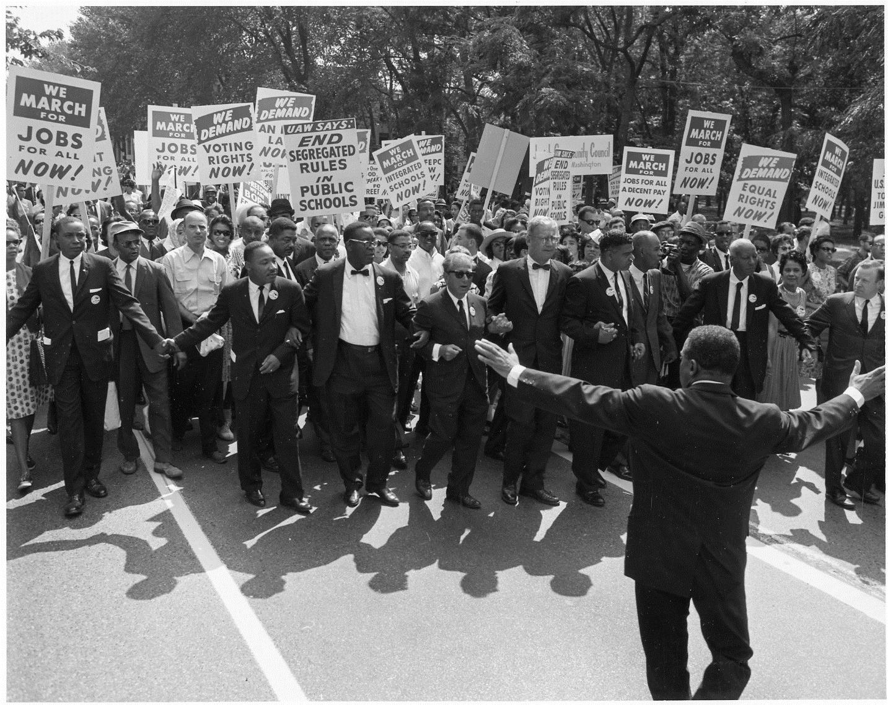
March on Washington for Jobs and Freedom
This image relates to the Civil Rights Buttons.
Credit Line: National Archives
no known copyright restrictions
Please note this image is of lower resolution and is best displayed on a projection screen or digital monitor.
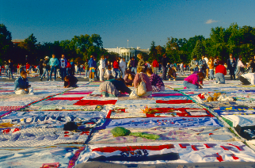
AIDS Memorial Quilt on the National Mall
This image relates to the AIDS Memorial Quilt Panel.
Credit Line: Smithsonian Institution Archives. Image # 89-20237.

Woman Suffrage Banner
Date: 1913
Credit line: Collection of the National Museum of American History

Civil Rights Buttons
Date: 1963
Credit Line: Collection of the National Museum of American History

AIDS Memorial Quilt Panel
Date: 1987
Credit Line: In memory of Roger Lyon, Division of Medicine & Science, National Museum of American History

