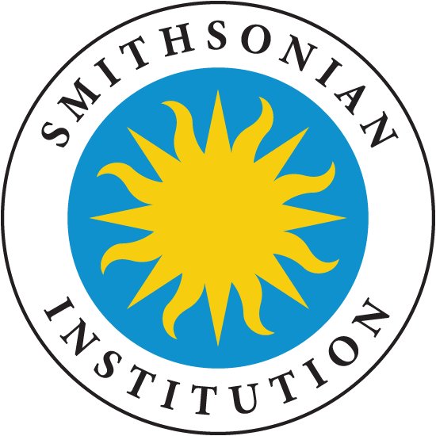
Smithsonian DIY Exhibit Available for American Spaces:
“Outbreak: Epidemics in a Connected World”

ECA’s Office of American Spaces would like to highlight the Smithsonian DIY 16-panel exhibit (graphics and content available for no cost to download with required signed user agreement) promoting global health security that may be used in American Spaces worldwide.

Building global health security capacity remains a priority of the U.S. National Security Strategy and U.S. National Biodefense Strategy. The United States is committed to collaborating with countries to invest in basic health care systems and address infectious diseases such as HIV/AIDS, malaria, Ebola, Zika, and influenza.

The Smithsonian Institution’s National Museum of Natural History (NMNH) is offering a free Do-It-Yourself print-on-demand exhibit called Outbreak: Epidemics in a Connected World – an extension of the current temporary exhibit in NMNH running until 2021 – that would be excellent for U.S. Mission and American Spaces’ programs promoting global health security. There are 16 pre-designed panels with two customizable templates, along with A/V and a resource guide, that share important information about diseases and how a range of public health professionals prevent, detect, and respond to infectious diseases, such as HIV/AIDS, Ebola virus, influenza, Zika virus, and others.
Sample Panels
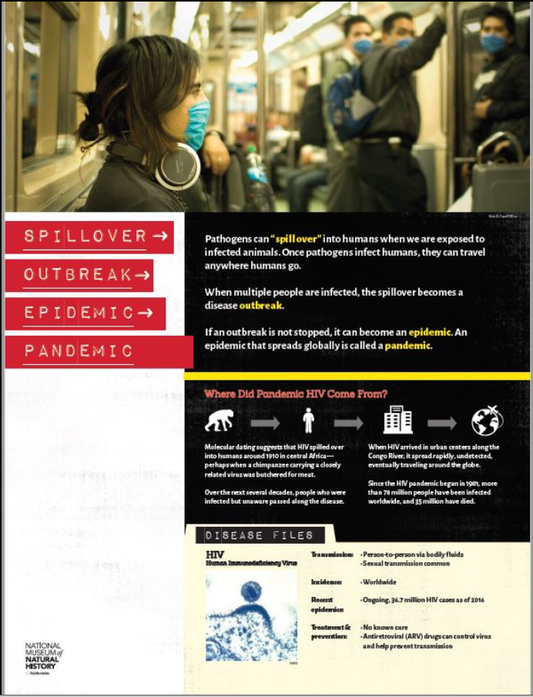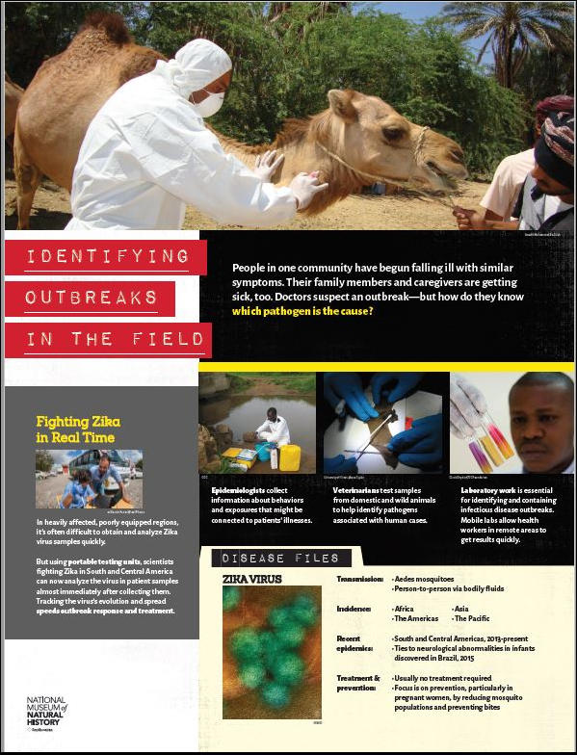

Some posts and American Spaces may already be aware of this resource, since the Outbreak DIY exhibit was communicated through different channels. The Office of American Spaces is coordinating with other Department bureaus, including the Bureau of Oceans and International and Scientific Affairs (OES), the Office of Global Health Diplomacy (GHD) and Bureau of Educational and Cultural Affairs (ECA), and we recommend that PAOs collaborate with ESTH officers to coordinate overall strategic programming around this exhibit. Posts can sign the Memorandum of Agreement with the Smithsonian on behalf of their American Spaces that have the capability and interest. [Note: Individual American Spaces may also sign their own Memoranda of Agreement. In this case, we recommend that the American Space coordinate with and cc: the Embassy/Consulate POC.]

Posts/American Spaces may consider tying the Outbreak exhibit for global health security programs, such as around World Health Day on April 7. A full list of dates to consider can be found at http://bit.ly/CDCHlthDys.

Here are specific details:
- Signing Up and Receiving Files: For posts/American Spaces interested in exhibiting the panels, the POC must complete the DIY User Application and sign the Memorandum of Agreement (links for both documents below) and send both back to the Smithsonian at NMNH-ExhibitsDIY@si.edu. After completing these items, you will also receive educational materials, including online games, blueprints for printing a virus on a 3D printer, etc., which you can use for programming.

- Exhibition: You do NOT need to display all 16 panels for your exhibition. The only required display is the title panel. There is no mandated length of time for your exhibition. You decide what works best for you. The actual physical Outbreak exhibition at the Smithsonian NMNH remains open until 2021, and you can use the DIY exhibit within the same time frame. You can also consider a digital exhibition in case there are budget constraints; the formatting of the panels also allows for a digital-only display.

- Customization: In addition to the 16 panels, local customization is possible with two, blank templates that you can use to tell stories and information that are important in your communities. Additionally, posts might use artifacts, objects, and locally made artwork (i.e., from a contest), a film, or other educational materials/games to feature community heroes, success stories, and/or contextualize the exhibit to the local experience.

- Languages: This exhibit is available in English, Spanish, French, Arabic, and Chinese (both simplified and traditional). If you do any local translation, please send your translated panels back to the Smithsonian to help expand their language offerings. Some other languages may already be available (translations done by other hosting institutions), and you can ask the Smithsonian directly.

- File Format: Pre-designed and translated panels are in PDF format. Posts/American Spaces should work with their local printers directly for poster production.

- Reporting: Posts/American Spaces are requested to report back to the Smithsonian the results of their exhibition/programs, using an evaluation form created by the Outbreak curation team. Please cc: the Office of American Spaces (americanspaces@state.gov) for our information.

- Promotion: Marketing folder includes preapproved templates for promoting the exhibit. Please use #Outbreak DIY and #Outbreak if posting on social media platforms.

The following documents may be accessed via the links below:
- Outbreak Informational Handout (2 pages): https://app.box.com/s/xrwfojf8s97ycqdfhy3aydp8iilzayqb
- Outbreak Do-It-Yourself User Application: https://app.box.com/s/ygsb0354ffgztpnnsenrt84bpq7brsqz
- Outbreak Memorandum of Agreement and License Agreement: https://app.box.com/s/6jernrjm2fgbj6y1ucq0uwp58kj5i7i3
- DIY Sample Panels: https://app.box.com/s/gzxr6xhguqpgzf4lbdzt6oqjs0373b9v and https://app.box.com/s/x949 n0t8hstszvuzedzp8asy44jvcksh

We hope posts and American Spaces will be able to take advantage of this great resource and opportunity. Please let us know if you have any questions at americanspaces@state.gov, and you can also contact the Smithsonian directly at NMNH-ExhibitsDIY@si.edu.

