The Right to Vote
THEMES: civic engagement, voting, participatory politics, rights, responsibility, diversity, democracy
SUMMARY: This program teaches participants about the right to vote as a mechanism of change and civic engagement by highlighting various American stories about voting. Participants will learn about the importance and significance of voting by listening to Americans talk about their personal experiences and examining primary source documents encouraging citizens to vote. This program includes a hands-on activity and optional lesson extensions.
The program materials include five high-quality photographs of museum objects from Smithsonian’s National Museum of American History.
LESSON SNAPSHOT:
TIME | SKILLS | TECHNOLOGY | MATERIALS | PROJECT
1.5 – 2 hours | Creative design, self-expression, analytical thinking | A computer and projector or digital monitor to display images to the group are optional, but recommended. An internet connection.  Computers with graphic design software, such as Photoshop or Lightroom* are also optional for the design activity. | Provided in this packet: All instructions for leading a program and hands-on activity; high-quality images (linked); optional image handouts.  Additional materials needed: A whiteboard or other writable surface, printer paper, a box, hat, or another container used to collect votes. A variety of art materials for a hands-on activity, such as construction paper, cardboard, colored pencils, pens, markers, scissors, glue, tape, and more. | Participants will use observation and analysis skills to discuss objects from U.S. history.  Optional lesson extension: Participants will then take inspiration from those objects to create their own object and message that expresses their voting rights.

* Please note these software examples are intended to provide ideas for facilitating your program. The Smithsonian Institution did not create the software listed and does not specifically endorse these products or services.

LESSON OUTCOMES | Participants should demonstrate an understanding of the importance of voting and the value of many voices participating in American democracy.
FACILITATOR PREPARATION | The facilitator should spend time reviewing the contents of this packet to become familiar with the material, especially with the overview of voting in the United States. The facilitator could also print the images of Smithsonian objects and the vocabulary list.

VOCABULARY | Anonymous: not named or identified; made or done by someone unknown  Ballot: a ticket or piece of paper used to vote in an election  Ballot box: a sealed box into which voters put completed ballots during an election, ensuring anonymity; may also be used to refer to elections or other occasions when people officially vote  Citizen: a member of a state or nation  Citizenship: the status of being given the rights, privileges, and duties of a citizen  Diversity: being composed of different elements or qualities; the state of having people from different cultures in a group or organization  Election: the act of selecting someone or something; the exercise of deliberate choice  Observer: a representative sent to observe but not participate officially in an activity (such as an election). Observers may monitor elections to assess the conduct of an election process with the goal of ensuring electoral integrity  Polls: the official location where people vote  Register: official list of citizens who are eligible to vote  Right: the fundamental rules about what is allowed of people or owed to people, based on morals, ethics, and justice  Vote:  - (noun): a formal expression of opinion or choice  - (verb): to express a wish or choice; to elect, choose, decide, pass, defeat, grant, or make legal  Voter registration: requirement of citizens to add their name to an official list, or register, in order to vote  Definitions provided by Merriam-Webster, Oxford, and Cambridge English Dictionaries.

DETAILED LESSON PLAN:
Introduction:  What is voting?  Introduce participants to the basics of voting, and lead participants in a voting activity  (10-15 minutes) | - Begin the program by explaining to participants that they are going to decide on something together – they are going to vote in an election.  - Discuss the words ‘vote’ and ‘election’ with the group. You may wish to ask participants to share their own definition of each word before referencing the definitions in the vocabulary list included in this packet.  - The facilitator should select one topic for the vote and determine the groups who will be eligible to vote in each election. Depending on the time available and the number of participants, the facilitator can use one or multiple topics for the vote. The facilitator could also select one topic and change the eligible voting groups to compare outcomes of each election.  - Possible voting topics include:  - Choose between two snacks and the winning snack is chosen to eat  - Choose between writing their name with their left or right hand  - Choose between two different seating arrangements  - Possible voting groups include:  - Only left-handed writers  - Only participants wearing blue (or another color)  - Only participants with birthdays on odd-numbered days (or even-numbered days)  - Only participants wearing sneakers or shoes with laces  - Share the topic of the vote with the group by writing it on the whiteboard or other writable surface. Explain that the outcome of the vote will affect everyone. In this scenario, only the population of the class with the right to vote will be able to express their opinion and impact the final decision.  - After clarifying who will be able to vote, the facilitator should carry out the vote. Everyone eligible to vote will indicate a preference for one choice or the other by raising their hand. Eligible voters will only be able to vote once. Once the participants have voted, write the outcome of the vote on the writable surface visible to the participants and, as necessary, perform any action associated with the outcome, such as distributing snacks, changing seats, etc.  Note for Facilitators: It is important to emphasize that in this type of vote, any participant can see how any other participant decided to vote. This process is not anonymous. Optional: Facilitators may want to introduce the concept of election observers, and assign a few of the non-voting participants as “observers” for this exercise.  - Ask the participants how they felt about voting – seek out the opinions of both those who were allowed to vote and those who were prevented from voting. Some sample questions could include:  - How did it feel to be included, or how did it feel to be left out of the process?  - Did you like the outcome, or would you have chosen something different if you had the chance to participate?  - How did it feel expressing your opinion through voting, knowing that other people in the room would not be able to do the same?  - Spend about three to five minutes discussing each question as a group.
Why is voting important?  Show participants personal stories about voting, emphasize the importance of voting  (20 minutes) | - Briefly explain the following to the group:  - The right to vote is a cornerstone of American democracy and is a fundamental right of American citizens, no matter their background.  - The first American citizens in 1776 decided that they wanted to form a government where the people could have direct input. Instead of a king making decisions on behalf of everyone, citizens would have the right and opportunity to make important decisions for the country.  - The definition of citizens who are able to vote has evolved over time. In the early history of the United States, voting was primarily restricted to white, male property owners. Members of minority groups, such as women, African Americans, Native Americans, or Asian Americans, faced various obstacles and discriminatory voting challenges in U.S. history. This timeline gives a glimpse into the history of voting rights in the United States: https://www.businessinsider.com/when-women-got-the-right-to-vote-american-voting-rights-timeline-2018-10  - Today, American citizens have the right to express their opinions on important issues by voting in regularly-held elections. A citizen must be at least 18 years old to vote in an election in the United States. The main exception is that felons in some states are not allowed to vote.  - Unlike some countries with compulsory voting, American citizens also have the freedom to not vote. According to the Pew Research Center, only 56% of the U.S. voting-age population cast ballots in the 2016 presidential election. There are many campaigns in America to encourage all eligible citizens to vote.  Note for Facilitators: These issues will be explored later in the lesson, but for now the facilitator will lead participants in a short discussion about why voting is so important – especially today.  Video + Discussion  - Explain to the group that you will be watching a short video about voting in the United States. Ask the group to consider the following question as they watch: why is voting important, and how do people feel about voting?  - Show the “Why do you Vote?” video from the Smithsonian’s National Museum of American History (run time: 4:16).  - Link to video (found at the bottom of the webpage): http://americanhistory.si.edu/democracy-exhibition/vote-voice. Facilitators should watch the video ahead of time to determine if the video would be suitable for their participants. Facilitators may wish to identify particular stories they may like to highlight and share with participants.  - Following the video, lead a discussion with the group using the following suggested prompts and questions:  - In the video, we see many different American citizens talking about the importance of voting as a duty, a right, and a privilege. Ask the participants: how many different stories did you hear?  For the facilitator’s reference, here are some examples:  - Young people voting for the first time  - Women  - African Americans  - Individuals with disabilities  - Some of these groups did not always have the right to vote, but we can hear in their stories how important this right is. Voting is important for everyone because it allows citizens to advocate for their opinions and engage on substantive issues. Ask participants:  - Which story did you find the most interesting?  - What kinds of words did the individuals use to describe their experience?  Facilitator Tips: You may find it useful to show the video more than once to facilitate the discussion and English language learning. Consider showing the video once before asking visitors each suggested question. Then, watch the video again so that this question is fresh for participants to consider as they watch. Depending on the size of the group, you may also wish to break up participants into small groups or pairs to allow them to discuss questions with each other. Then, bring the full group back together and ask participants what they discussed or thought about the video and the issues it raises.  Facilitators may also consider distributing a handout with the questions and/or writing the questions on a whiteboard or other writable surface for participants to consider as they watch the video. If participants are working in smaller groups or pairs, consider having each group focus on 1-2 people from the video. Groups can then take turns reporting out about why voting is significant to the individuals they have been assigned.
What do we vote about?  Lead participants to consider what issues they could vote on in an election  (15-20 minutes) | - Explain to the group: When Americans go to vote, they could be voting for a candidate for political office or on a specific issue. Both are important!  - Refer to the first image including in this packet, the voter handbill from the 1920s, on page 11. Display the provided image on a projector, digital monitor, printing and displaying the high-resolution image, or simply using the handouts in this packet.  - Ask a participant to read all of the issues listed that Americans can decide by voting, as described by the League of Women Voters. The facilitator can consider using a versatile audience/student participation method here, such as “popcorn” the reading by asking participants to read a word and then call on another participant to read the next one, and so on, for 10-15 seconds. Then, have the participants work in pairs to read/re-read the voter handbill together. The paired groups can also discuss issues that are important to them, in preparation for the next bullet point/activity.  - After this list has been read, ask participants to name the issues that are important to them. Write their responses on a whiteboard or other writable surface, so participants can see them and refer back to them. These issues could be from the list on the voter handbill or created by the participants themselves. Continue this exercise until at least 5-10 different issues have been named. Here are some examples, to be adapted by the facilitator based on the age group of the participants:  - Free time  - Lunch options  - Favorite athlete, musician, or actor/actress  - Cleaning up parks or playgrounds  - Funding for school programs  - Dress code  - School mascot  - LGBT rights  - Freedom of expression and speech  - Equality in sports, education, etc.
Who should vote?  Show and discuss images of objects from the Smithsonian National Museum of American History. Discuss with participants why diversity in voting is important.  (30-45 minutes) | - Now that participants have a better understanding of why people vote and the types of issues people vote about, the facilitator will lead a discussion with images of objects from the Smithsonian’s National Museum of American History (images are included in a handout in this packet) to facilitate understanding of who votes.  - Display the provided image of each object (four total) on a projector, digital monitor, or by printing and hanging the high-resolution images or using the handouts in this packet on pages 14-17. Read each of the following descriptions aloud to the group, or ask individuals to read aloud to the group.  - After each description has been read and participants have had a few minutes to study the image, ask the suggested discussion questions, at the end in bold below to facilitate discussion.  Note for Facilitators: An alternative format of discussion that promotes greater participation and engagement of the attendees would be to divide your participants into small groups (between 2-4 people per group). Consider giving each group one of the images below, and having the members of each group read the descriptions to each other and talk about the suggested discussion questions. Then, each group can present their image and ideas to the larger group.  If this activity is used in a classroom setting with computers, you may consider having the small groups create slides to present their ideas to the rest of the class. You may also consider having the students use the following framework as part of their discussion: http://www.pz.harvard.edu/resources/circle-of-viewpoints-vt  - The four images are:  - Register and Vote poster from 1972  As new and diverse groups of Americans won the right to vote, local and national concerns shifted from whether or not they could vote to whether or not they would vote. Native Americans first won the right to vote with the Snyder Act of 1924, which gave Native Americans born in the U.S. full citizenship. However, for many Native Americans it was still very difficult to vote – poll taxes, literacy tests, and intimidation kept Native Americans away from the polls. However, the Voting Rights Act in 1965 strengthened voting protections. This poster, created around that time, demonstrates the push to include more diverse voices in the voting process. The imagery of both peace (with the “peace sign”) and the traditional Native American headdress communicate the importance of voting as a right for this specific population.  Discussion Questions:  - Why is it important to include diverse voice in the voting process?  - Is this an effective poster? Why or why not?  - Hands that Pick Cotton poster from 1972  Though slavery ended in the United States in 1868 and African Americans were finally recognized as full U.S. citizens, many African Americans were prevented from voting for decades. Martin Luther King Jr. famously led the civil rights movement in the 1960s, and pushed for voting rights (among other things). The 1965 Voting Rights Act mentioned above finally made it possible for African Americans to vote regularly. One of the key aspects of voting protection is anonymity – the right to vote without anyone else knowing your vote. Prior to 1965, only 23% of voting-age African Americans were registered to vote. After the Voting Rights Act was passed, this number had jumped to 61% by 1969.  Discussion Questions:  - Who do you see in this poster? Who is the audience?  - What is the message of the poster and how is it conveyed?  - Woman’s voting poster from 1919  Women did not always have the right to vote in the United States. The 19th Amendment to the U.S. Constitution was passed in 1920, declaring for the first time that women, like men, deserve all the rights and responsibilities of citizenship, including voting. This sign, created the same year, was designed to be placed in the window of a home so that all who passed would know that the woman within had exercised her right under the 19th amendment and registered to vote. It also served as a reminder to other women to do the same.  Discussion Questions  - Why do you think this poster talks about the right to vote as a “responsibility?”  - What are other responsibilities of citizenship?  - Newsweek magazine cover from 1971  Unlike the other images, this image is not a poster encouraging people to vote. This is a cover from a popular American magazine. Until 1971, the voting age in the United States was 21. However, many Americans felt that this was unfair. Other rights and responsibilities of citizenship, such as military service, start at age 18. In 1971, the 26th Amendment to the U.S. Constitution lowered the voting age to 18. Voting is important, and people are invested in the results of every election. No one knew how 18-21 year olds would vote.  Discussion Questions:  - At what age do you think people should be allowed to vote? 18? 15? Why?  - Why do you think young people sometimes vote differently than other generations?  - After presenting the images, ask participants: What do these posters/images have in common? Spend 5-7 minutes discussing.  - These images all demonstrate the importance of voting to different underrepresented groups in the United States. Though each of these groups did not always have the right to vote, today any voting-age American citizen can participate in government by voting (with the exception of felons in some states). Each poster shows the importance of this right to each group, and attempts to encourage members of that group to exercise their right to vote.  Facilitator Tips:  - Help participants better understand the messages conveyed in the images of these objects by defining vocabulary terms, such as ballot box and citizenship.  - Depending on the size of the full group, consider dividing participants into four groups and providing each group with one image and description. Ask each group to spend time reading the description, individually or aloud, before discussing the questions associated with each. Give these smaller groups 10-15 minutes to discuss before bringing the entire group together for a readout on each of the objects.
Conclusion and final activity  Lead a follow-up vote to demonstrate lessons learned. Optional hands-on activity to create voting poster.  (15-20 minutes) | - Now that the participants are familiar with voting, the importance of voting, and the value of diversity in elections, return to the vote held at the beginning of the session. Explain that the group will be voting again on the same question, but this time everyone will have the right to participate.  - Provide each participants with a small slip of paper to cast their vote. They do not need to write their name on the ballot.  - Ask participants to write down their choice on a piece of paper and place it in a box, hat, or other container that guarantees anonymity. The facilitator should count the votes and tell participants the outcome.  - Conclude the lesson by asking participants the following questions for discussion:  - How was the vote different this time, as opposed to the first time?  - How do the participants who were not previously allowed to vote feel now?  - Which vote outcome is more representative of the opinions of the group: the results of a select group of individuals in the group or the results of full group participation?  - Now that participants have participated in a “mock election,” ask them to research any upcoming elections and the issues that will be voted on. To conclude the program, ask the following questions:  - Will they be voting? (if of age)  - Which issues are most important to them? Why?  - How has this program influenced whether they vote in the upcoming election?
Optional Lesson Extension A | In the extended version of this activity, participants will have the opportunity to create a poster or “vote” sign (like the ones displayed earlier) that expresses their own right to vote and why it is important. Use the voting topics created earlier on the board to get participants thinking about the right they have selected and the ways in which they want to communicate the importance of this right to others.  - These objects could contain a combination of words, images, or designs to convey or express the rights they have selected.  - Set out a variety of craft materials at each table while participants are discussing their rights. Materials could include a selection of the following: printer paper, construction paper, poster board, markers, pens, pipe cleaners, scissors, glue, tape, paint, or any other supplies you have available.  - While participants are working, walk around the room and talk with them about their poster. One possible question to ask: What rights are you thinking about in your design? Why did you choose these colors/shapes?  - Give participants a five-minute warning before the activity is finished to allow them time to finish their posters.  - After creating the voting poster, ask participants to explain their poster to the group, including the message and design choices they made and why. These posters created by the participants could be displayed near the voting posters provided in this packet to highlight the comparisons between the historic objects and creations of the participants.  Facilitator Tip: This activity can be completed with a variety of craft supplies. For a more technologically-advanced group of participants, consider conducting this activity using computer design software for digital skill-building opportunities. Facilitators could also consider working with partner contacts, such as USG exchange program alumni with expertise in this field, who would be willing work with participants in digital skills-building, using this topic as a prompt.
Optional Lesson Extension B | This extension activity may be done as a follow-up or in place of the extension activity above. Participants may choose to research/discuss populations with lower turnout in their own communities and discuss ways to reach them. As the participants think about creating a voting poster, some may choose to create posters that target specific under-represented voting populations.  Upon completion of the voting posters, ask participants to explain their posters, including who they believe are under-represented voting populations, how they can reach these groups, and how their posters can motivate these groups.  Facilitator Tip: This activity could be done in small groups, which allows for brainstorming together. Access to computers with internet would also be helpful for this activity, so that participants can conduct any necessary research. After the brainstorming/research phase (for example, 30 minutes), ask the groups to begin working on their poster or posters (they may choose to do a poster series). As with Optional Lesson Extension A, this activity can be completed with a variety of craft supplies. For a more technologically-advanced group of participants, consider conducting this activity using computer design software for digital skill-building opportunities.  Facilitators may also choose to divide this extension activity into two sessions, rather than completing the activity in one session.

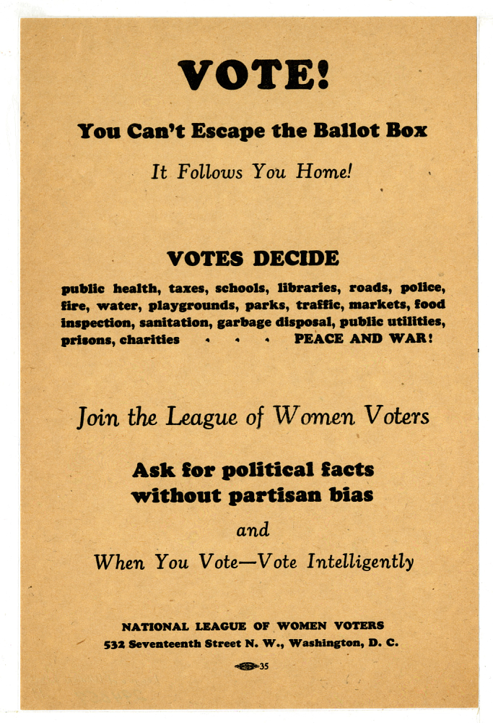
“Vote Handbill,” 1920s. National Museum of American History.
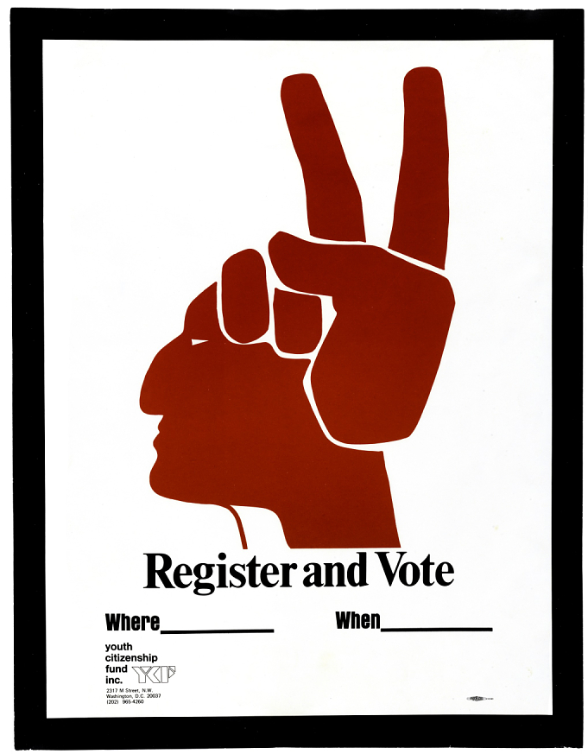
“Register and Vote” poster, 1972. National Museum of American History.
As new and diverse groups of Americans won the right to vote, local and national concerns shifted from whether or not they could vote to whether or not they would vote. Native Americans first won the right to vote with the Snyder Act of 1924, which gave Native Americans born in the U.S. full citizenship. However, for many Native Americans it was still very difficult to vote – poll taxes, literacy tests, and intimidation kept Native Americans away from the polls. However, the Voting Rights Act in 1965 strengthened voting protections. This poster, created around that time, demonstrates the push to include more diverse voices in the voting process. The imagery of both peace (with the “peace sign”) and the traditional Native American headdress communicate the importance of voting as a right for this specific population.

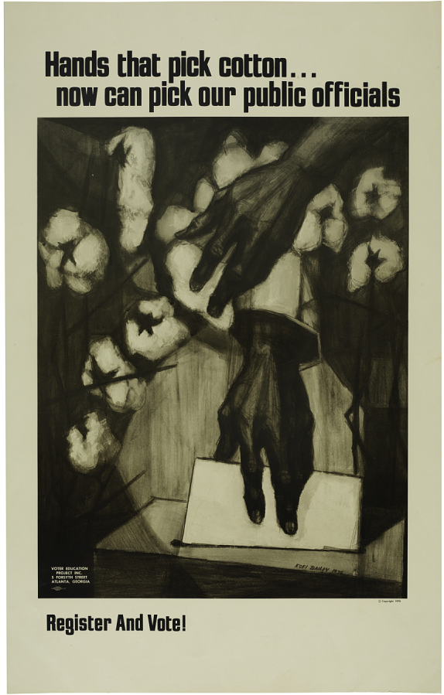

“Hands That Pick Cotton” poster, 1972. National Museum of American History.
Though slavery ended in the United States in 1868 and African Americans were finally recognized as full U.S. citizens, many African Americans were prevented from voting for decades. Martin Luther King Jr. famously led the civil rights movement in the 1960s, and pushed for voting rights (among other things). The 1965 Voting Rights Act mentioned above finally made it possible for African Americans to vote regularly. One of the key aspects of voting protection is anonymity – the right to vote without anyone else knowing your vote. Prior to 1965, only 23% of voting-age African Americans were registered to vote. After the Voting Rights Act was passed, this number had jumped to 61% by 1969.
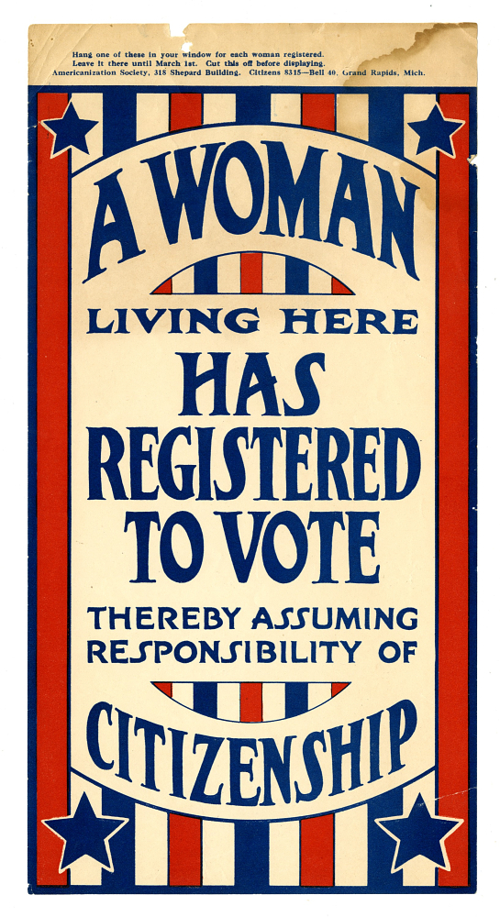
“A Woman Here Has Registered to Vote” poster, 1919. National Museum of American History.
Women did not always have the right to vote in the United States. The 19th Amendment to the U.S. Constitution was passed in 1920, declaring for the first time that women, like men, deserve all the rights and responsibilities of citizenship, including voting. This sign, created the same year, was designed to be placed in the window of a home so that all who passed would know that the woman within had exercised her right under the 19th amendment and registered to vote. It also served as a reminder to other women to do the same.

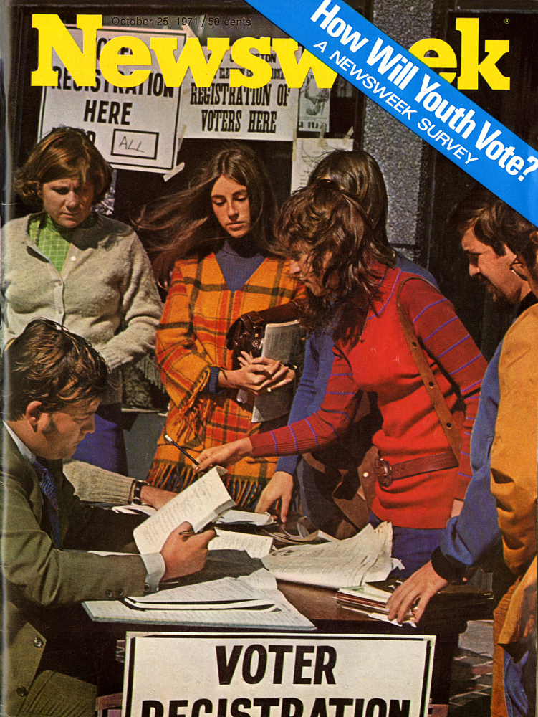

Newsweek, October 25, 1971. National Museum of American History.
Unlike the other images, this image is not a poster encouraging people to vote. This is a cover from a popular American magazine. Until 1971, the voting age in the United States was 21. However, many Americans felt that this was unfair. Other rights and responsibilities of citizenship, such as military service, started at age 18. In 1971, the 26th Amendment to the Constitution lowered the voting age to 18. Voting is important, and people are invested in the results of every election. No one knew how 18-21 year olds would vote.

