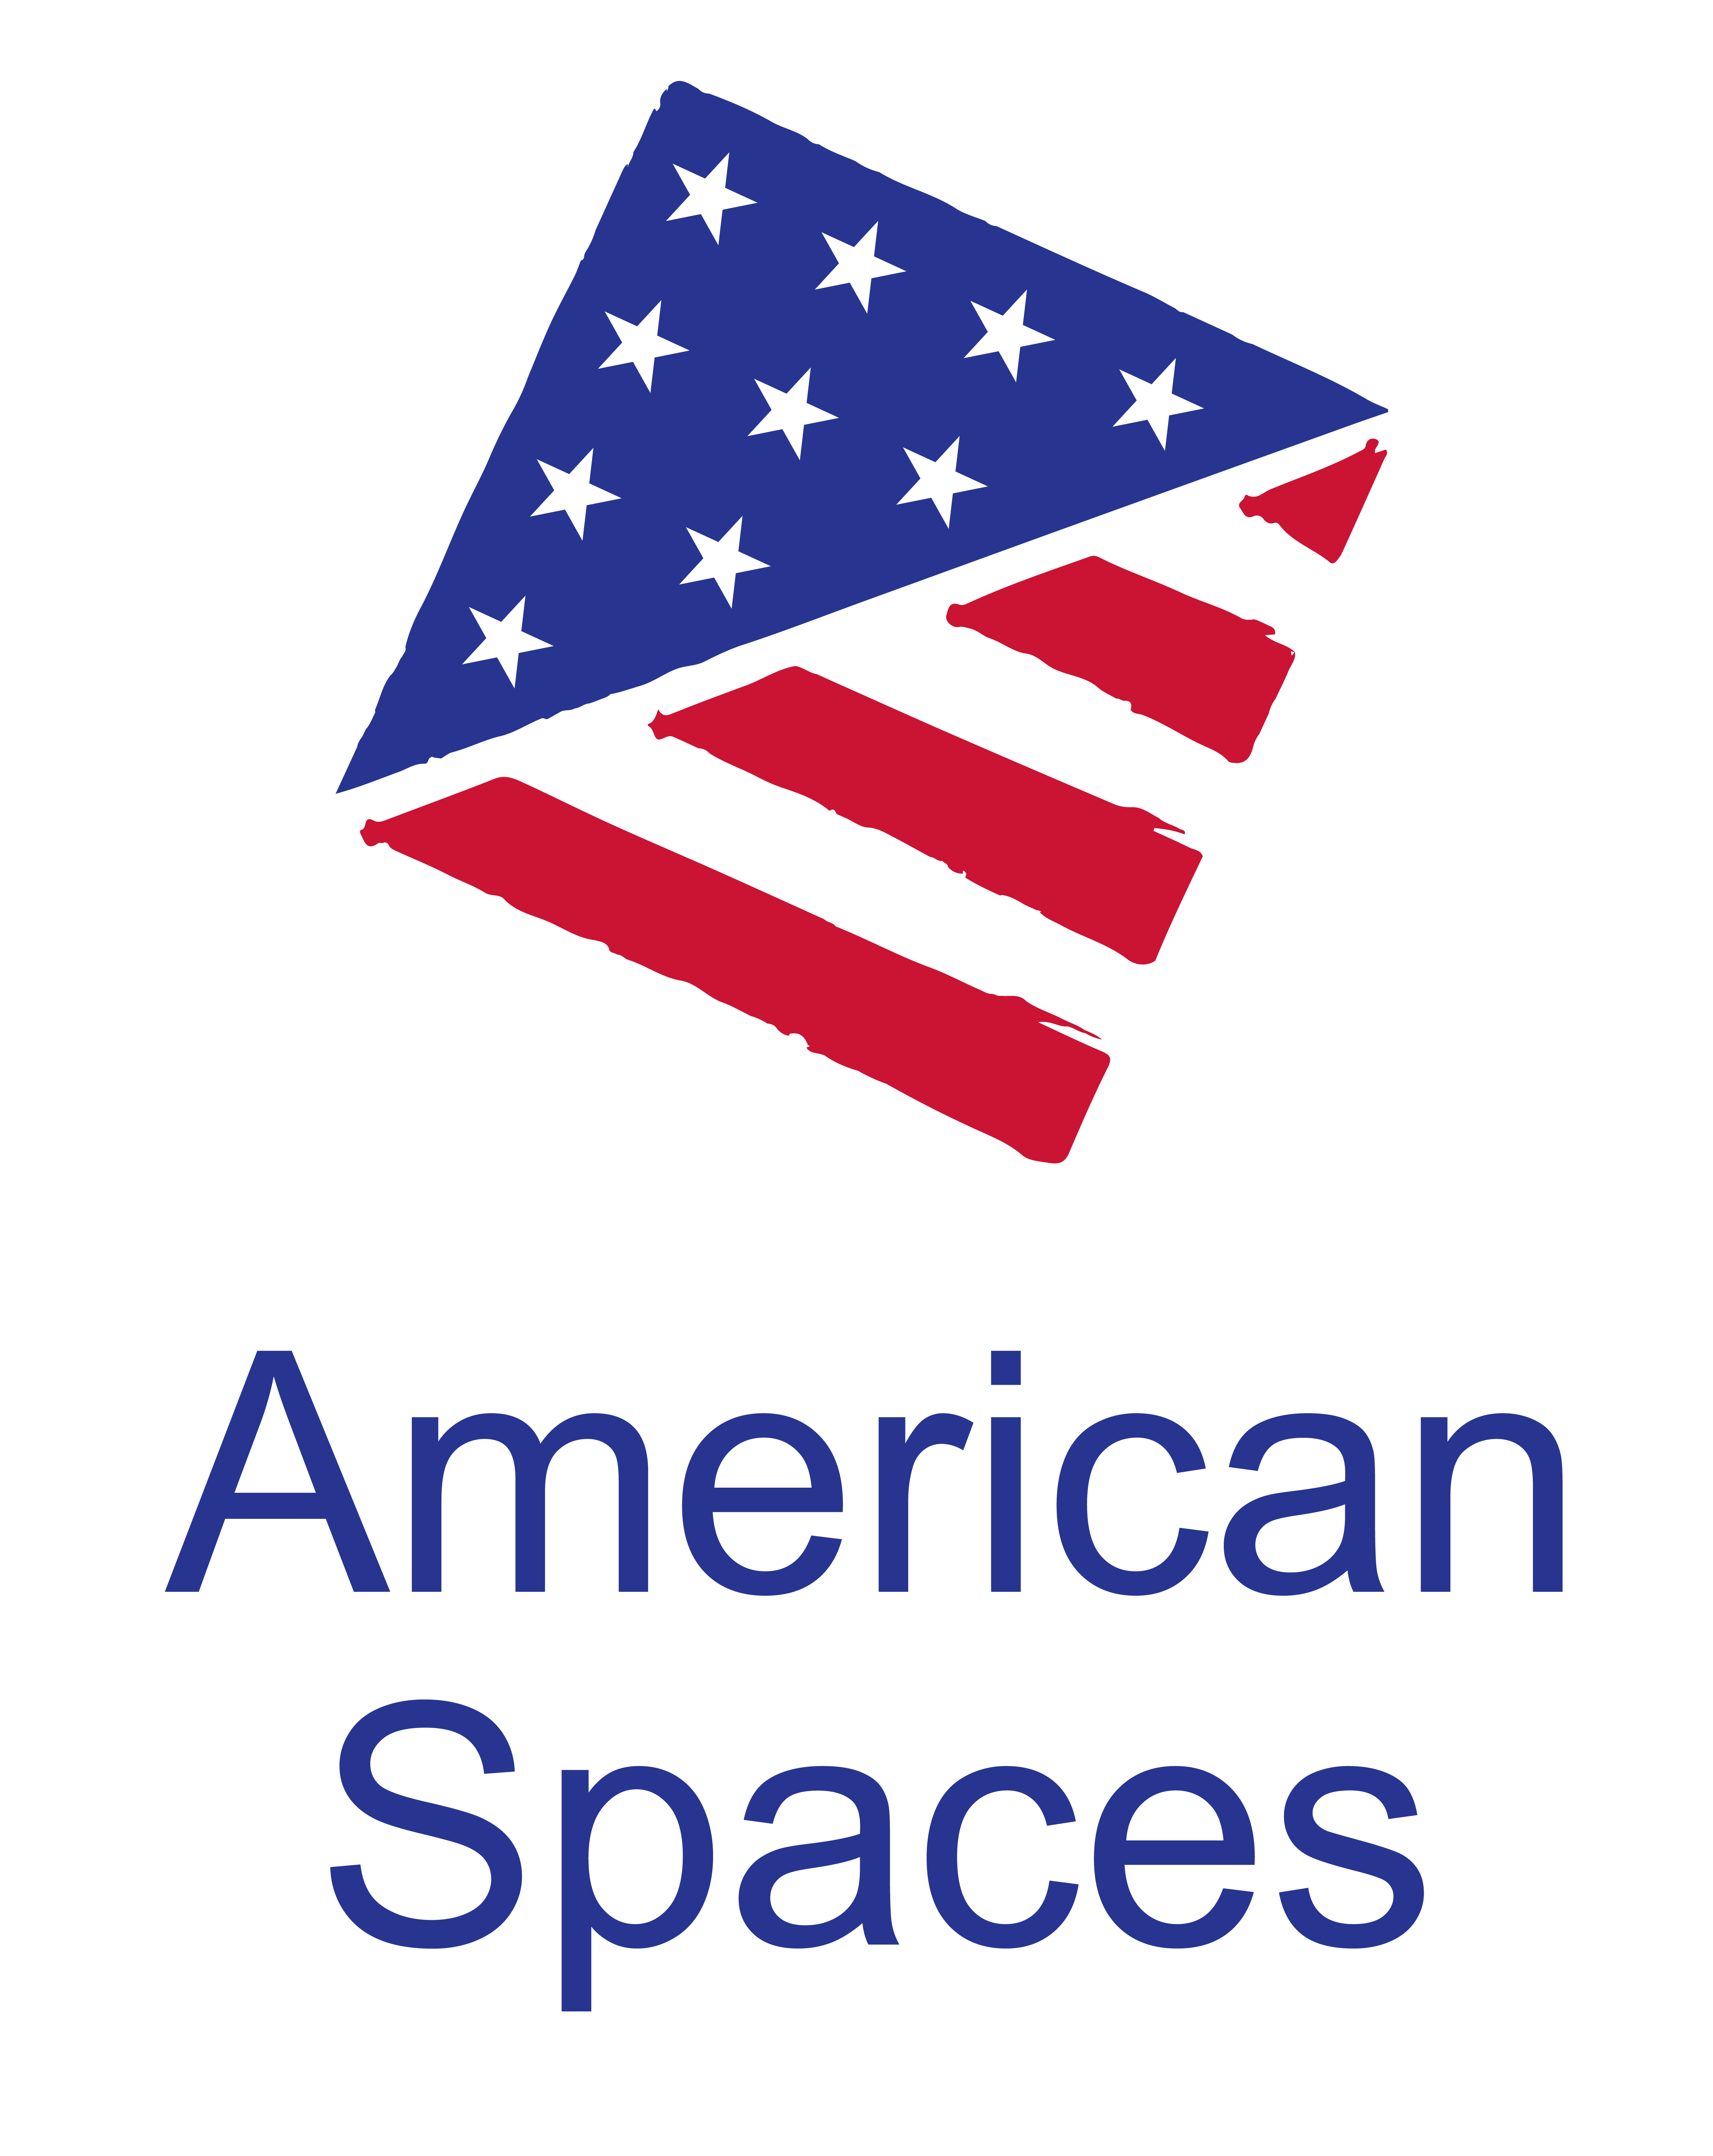
American Spaces Programming Resources

World Space Week and STEM

Please note:
The resources provided here are not required programs. The Office of American Spaces recommends collaborating with the U.S. Embassy’s or Consulate’s Public Affairs Section on the programs offered in American Spaces.

World Space Week is observed from October 4-10 annually throughout the world. World Space Week is an international celebration of the contribution that space science and technology makes to the betterment of the human condition. The World Space Week 2018 theme is “Space Unites the World.” (www.worldspaceweek.org)

Programming Resources

- NASA for Educators Resources (https://www.nasa.gov/audience/foreducators/index.html):
(Website is full of resources, including lesson plans, videos, images, etc. Resources mentioned below can be incorporated into a 45-60 minute talk or English Conversation Club; internet connection required for showing videos and images below.)
  - Picture/Slide Show: https://www.nasa.gov/specials/kidsclub/pictureshow/index.html
    - Nearly 90 pictures with explanations
  - “STEMonstrations” Video and Lesson Plan on Water Filtration Aboard International Space Station: https://www.nasa.gov/stemonstrations-water-filtration.html
    - 3+ minute video with astronaut aboard International Space Station
    - 12-page lesson plan included; click on “Water Filtration” hyperlink
  - More “STEMonstrations” video and lesson plans for additional topics can be found here: https://www.nasa.gov/stemonstrations

- World Space Week Resources
(Resources below include science and math activities, and are designed for use with all levels of students (primary through high schools). Many activities include scientific and technical English terms, so English language level may be medium-high.)

  - Teacher Activity Guide: http://www.worldspaceweek.org/uploads/WSW_Teacher_Activity_Guide1.pdf
    - A possible program may include the “Protect Your ‘Eggnaut’” activity on page 7.
  - World Space Week Heinlein Teacher Guide: http://www.worldspaceweek.org/events/event-ideas/educators/
    - Offers a collection of science and language arts activities
    - Available in multiple languages
    - Based on the book “Have Spacesuit – Will Travel” by Robert A. Heinlein

Film Programming Packages
- Film: The Martian
  - 1 hour 42 minutes – After an astronaut becomes stranded on Mars, he must figure out how to survive and send a message to Earth that he is alive.
  - Movie Programming Kit (accessible here: https://americanspaces.state.gov/programming/movie-kits/)
  - Posts/American Spaces need to procure film on own

- Smithsonian Videos for American Spaces
  - Each Smithsonian video comes with English conversation club questions
  - Adam Steltzner Looks Beyond Mars (1 min 43 seconds): https://americanspaces.smithsonian.com/videos/category/education/adam-steltzner-looks-beyond-mars/
  - What is Next in Space Exploration (15 mins 8 seconds): https://americanspaces.smithsonian.com/videos/category/civil-society/leaving-earth-a-deeper-future-or-science-fi/
  - Space Shuttle Discovery’s Biggest Accomplishments (3 mins) https://americanspaces.smithsonian.com/videos/category/civil-society/space-shuttle-discoverys-biggest-accomplish_1/

Suggested Movies Covered Under MPLC Licensing Agreement
- https://americanspaces.state.gov/programming/the-motion-picture-licensing-corporation-agreement/)
- Visit the Managing American Spaces website to find suggested movies covered by the Motion Picture Licensing Corporation (MPLC) agreement that may be shown as part of World Space Week. For a listing of ECA-suggested film titles:
- Under the first FAQ (Suggested Film Titles by Category/Genre/Theme), click on “list of film titles (xlsx 748)”
- On the bottom of the spreadsheet, scroll to the tab that says “Space Travel”
- Note: The inclusion of each title represents a suggested and/or potentially relevant film, not an endorsement. All posts/Spaces are advised to preview film titles privately before public screenings to ensure that all thematic material and content is culturally and programmatically appropriate for their intended audiences.
- Posts will need to procure films on own.

eShop Collections
*eShop collections include a selection of products, including books, games, posters, kits, etc, on specific topics that may be used for programs to engage target audiences.
- Space -- https://eshop.state.gov/STEM/Space
- STEM -- https://eshop.state.gov/STEM

Written/Photo/Video Resources
- Share America article – Meet Astronauts Launching New U.S. Spaceflight Era -- https://share.america.gov/meet-astronauts-launching-new-era-of-u-s-spaceflight/
- Share America article – To the moon and beyond! -- https://share.america.gov/american-astronauts-new-destination-moon/
- Share America article – Legacy of Sally Ride -- https://share.america.gov/legacy-of-americas-first-woman-in-space/
- IIP Photo Archive – Space -- https://www.flickr.com/photos/iip-photo-archive/albums/72157665028512494
- NASA Image and Video Library -- https://images.nasa.gov/

Opportunity to Participate in NASA’s International Space Apps Challenge
- 48-hour Hackathon from October 19-21, 2018
  - International teams of coders, scientists, designers, storytellers, makers, and builders come together to address challenges we face on Earth and in space.
  - No central organizer; check out the following link for more info and to see if your city is participating in the hackathon: https://2018.spaceappschallenge.org/

